**http://www.intosaiksc.org/html/images/logo.png**

**Progress Report**

**Project**

**“Citizen Participation in Public Audit”**

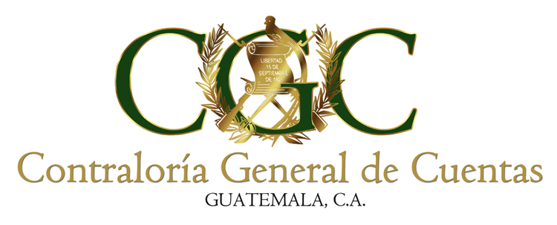

**August, 2018**

1. RESPONSIBLE SAI’s

|  |  |  |  |
| --- | --- | --- | --- |
| Líder: | Guatemala | | |
| Vice leader: | Philippines | | |
| Members : | Afghanistan | Bangladesh | Bhutan |
|  | Denmark | ECA | Iraq |
|  | India | Maldives | Myanmar |
|  | Nepal | Pakistan | Suriname |
|  | Uganda | Zambia |  |

1. Project scope

The Research will cover various SAI’s experiences on engaging/partnering with citizens/civil society in the performance of their mandates/functions and the legal and technical bases for these engagements/partnerships; and, country experiences of their citizens/civil society on organizing, pushing for their advocacies, obtaining logistical support, engaging/partnering with Government Entities, including SAIs, and meeting challenges they encountered.

1. Work done to date

**April – August 2017**

Preparing and revising the Draft of the Project Initiation Document –PID- by SAI Guatemala and SAI Philippines.

**August 2017**

 At the 9th KSC Steering Committee meeting at Bali, Project Initiation Document –PID-, was approved. KSC requested some updates on the document.

**September 2017**

The SAI Philippines sent to SAI Guatemala, the Project Initiation Document -PID-, contains the updates for review or approval.

**November 2017**

Sending the Project Initiation Document -PID- updated and approved to the KSC, leader, vice-leader and team members.

**December 2017- February 2018**

Team members analyzing the Project Initiation Document -PID- and begin a research study on literature and related documents.

Preparing and revising the Citizen/CSO Experience Document and SAI Country Experience Document, to be used by the Research Project Group in developing the initial draft of the Case Document.

**March – July 2018**

Support material was obtained and analyzed on the subject and made the necessary documents for project members (working group) to obtain the pertinent information; the documents produced are the following:

- Citizen /CSO Experience Document

- Country Experince Document, Supreme Audit Institutions –SAI-

The data gathered of both documents, will be consolidated into a ***Case Document: Country Experiences on Citizen Engagements/Partnerships in the Public Audit Process and Other Activities of SAIs.***

The first document was sent to the SAI Philippines (Vice leader) for their comments and suggestions, which were included in the final document, which was sending to the project members.

The second document was sent to the SAI Philippines (Vice leader) for their comments and suggestions, which we are waiting for.

1. Work to do

* Preparing the Research Work Plan – in a meeting by the Research Project Team.
* Establish the number of SAI members of the project team. (several SAIs, not yet confirmed his participation)
* Gathering Data from SAIs & from Partner Citizens/CSOs (Country Experience Document for SAIs &Citizen/CSO Experience Document for citizen/CSO partners)

1. Investigation status

On Process, Project Plan Activities

1. Results achieved

Project Initiation Document -PID-, approved

Citizen/CSO Experience Document, Shared

First Draft of the SAIs Country Experience Document, Reviewing