International Organization of Supreme Audit Institutions

Organisation Internationale des Institutions Supérieures de Contrôle des Finances Publiques

Internationale Organisation der Obersten Rechnungskontrollbehörden

Organización Internacional de las Entidades Fiscalizadoras Superiores

Bild 4

**9th Meeting of the  
Steering Committee of the INTOSAI Committee on Knowledge Sharing and Knowledge Services (KSC)**

Bali, Indonesia

23–25 August 2017

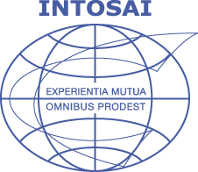

|  |
| --- |
| INTOSAI General Secretariat  Agenda item 4 |

|  |
| --- |
|  |

Table of Contents

Introduction 2

1. XXII INCOSAI 2016 2

2. UN Sustainable Development Goals and INTOSAI 3

3. 24th UN/INTOSAI Symposium in Vienna 4

4. XXIII INCOSAI 2019 5

5. 70th Governing Board Meeting November 2017 6

# Introduction

It is a great honour and pleasure for the INTOSAI General Secretariat to participate in the 9th Meeting of the INTOSAI Knowledge Sharing Steering Committee.

The INTOSAI General Secretariat highly appreciates the commitment of all KSC members as we need as much input from as many SAIs as possible to create a broad basis for government auditing especially taking into account the recommendations of the new INTOSAI Strategic Plan 2017–2002 approved at XXII INCOSAI in Abu Dhabi last December.

In the following some words on the recent developments in INTOSAI:

# 1. XXII INCOSAI 2016

The last INCOSAI was celebrated – for sure with the attendance of numerous KSC members – in Abu Dhabi and here some of the main decisions:

• endorsement of the INTOSAI Strategic Plan 2017–2022, which envisages to put into practice, in a comprehensive, transparent and efficient way, the contribution of SAIs to enhancing accountability and transparency in public administration for the benefit of citizens worldwide;

• for the first time the important role of the seven INTOSAI Regional Organizations has been underlined; e.g. one of the five cross-cutting priorities is dedicated to the regions: *“Building upon, leveraging, and facilitating cooperation and professionalism among the Regional Organizations of INTOSAI”;*

• endorsement of the revised Due Process for the INTOSAI Framework for Professional Pronouncements (IFPP);

• endorsement of the INTOSAI Framework for Professional Pronouncements (IFPP), which comprises all INTOSAI products broken down by three categories:

1. INTOSAI Principles,

2. INTOSAI Standards and

3. INTOSAI Guidelines.

The IFPP will replace the former ISSAI framework;

• creation of a Forum for INTOSAI Professional Pronouncements (FIPP), the INTOSAI standard-setting body, which revises and approves professional pronouncements, such as the ISSAIs, according to the Due Process;

• endorsement of the reviewed INTOSAI Statutes, which brought about a closer alignment with the current structure, strategy and objectives in order to better meet the needs of its members and stakeholders and giving also more importance to the regions;

• adoption of the SAI Performance Measurement Framework (SAI PMF);

• creation of a Regional Forum for Capacity Development within the framework of the CBC (Strategic Goal 2);

• approval of the 2017 priority theme “Implementation of the INTOSAI Strategic Plan 2017‑2022 based on the Abu Dhabi Declaration, with particular focus on the 5 strategic cross-cutting priorities”; as well as

# 2. UN Sustainable Development Goals and INTOSAI

The before mentioned INTOSAI Strategic Plan 2017–2022 also established as another cross-cutting priority the UN Sustainable Development Goals (SDGs): *“Contributing to the follow-up and review of the SDGs within the context of each nation’s specific sustainable development efforts and SAIs’ individual mandates”* as well as the following four approaches – also laid down in the Abu Dhabi Declaration - where SAIs can expect to make valuable contributions to the implementation of the SDGs:

1. Auditing national systems of follow-up (assessing the readiness of national systems to report on progress towards the achievement of the SDGs);

2. Performance audit of SDG programmes (undertaking performance audits that examine key government programmes contributing to the SDGs);

3. Assessing and supporting SDG 16 (assessing and supporting the implementation of SDG 16, which relates to transparent, efficient, and accountable institutions);

4. Being models of transparency and accountability (being models of transparency and accountability in their own operations).

Due to the broad scope of the SDGs, many of the issues they address fall within the scope of SAIs’ audit work and SAIs are providing advice for and assessment of the preparation and the monitoring of the implementation of the SDGs, which gives SAIs the possibility to play a key role in supporting the follow-up and review of the SDGs.

Each of the four above-mentioned approaches shall be supported by a dedicated framework, which will help INTOSAI compile the key findings from SAIs’ work in the respective areas.

The proposed frameworks to be developed for the implementation of the four approaches include in detail

• an auditing preparedness model containing seven key elements in order to assess the preparedness of national governments to implement the SDGs;

• an audit findings framework as a tool to aggregate performance audit results at regional as well as the global level;

• a PFM (public financial management) framework assessing the functionality of the national public financial management systems; and

• a global SAI performance evaluation framework that can showcase how SAIs across the globe are performing and how this performance is improving by re-porting on a few essential indicators.

On July 20 and 21 the UN in cooperation with IDI held in the UN headquarters in New York SAI leadership and stakeholder meeting on “Auditing preparedness for the implementation of the Sustainable Development Goals (SDGs)” with among others active participation of the KSC, CBC and GS INTOSAI.

# 3. 24th UN/INTOSAI Symposium in Vienna

The 24th UN/INTOSAI Symposium, which was jointly organized by the INTOSAI General Secretariat and the United Nations Department of Economic and Social Affairs (UN DESA), was held at the Vienna International Centre in Vienna from 31 May to 2 June 2017.

Entitled *"Digitalization, open data and data mining: relevance and implications for SAIs’ audit work and for enhancing their contributions to the follow-up and review of the SDGs"*, the 24th UN/INTOSAI Symposium focused on two themes that will be of considerable importance for the work of SAIs in the forthcoming years:

1. the implications of digitalization, open data and data mining for the audit work of SAIs, and

2. the possibilities of SAIs to contribute to the implementation of the 2030 Agenda and the UN Sustainable Development Goals.

In this context, the participants engaged in intensive discussions on the following issues:

• What are the opportunities, but also the challenges, created by digitalization, open data and data mining for the audit work of SAIs?

• What kind of practical experiences have SAIs made in the framework of their audits with regard to digitalization, open data and data mining and which best-practice examples can be derived therefrom?

• How can SAIs – as a follow-up to the results of INCOSAI XXII in Abu Dhabi 2016 – contribute to the implementation of the SDGs in the best possible manner?

The function of the technical chair was excellently carried out by Mr Chris Mihm of the SAI of the United States of America.

The event was attended by more than 150 participants, and among these were heads and high-ranking representatives of more than 70 SAIs and of several international institutions (UN DESA, UN OIOS, International Budget Partnership, the Austrian Development Agency – ADA and the German Society for International Cooperation – GIZ).

[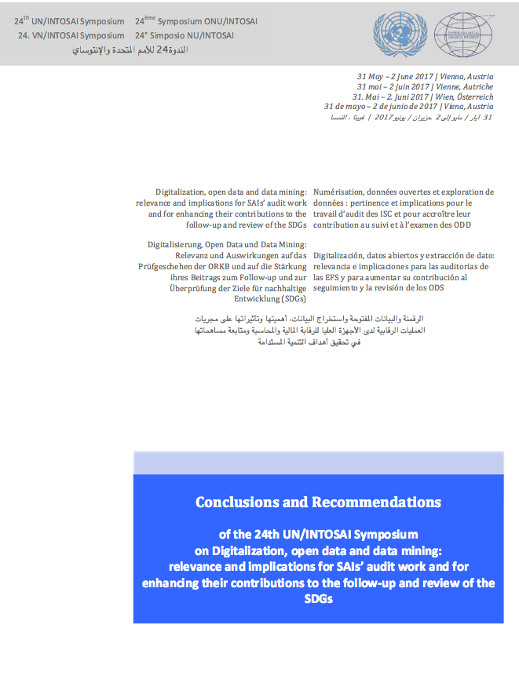](http://www.intosai.org/fileadmin/downloads/downloads/5_events/symposia/2017_24th_symposia/EN_Final_Conclusions_and_Recommendations.pdf)The discussions showed that new information technologies and possibilities for the use of data entail profound opportunities, but also great challenges for SAIs. SAIs are aware of the fact that in times of increasingly available information they are playing a highly important role as the providers of qualified information through their audits. They, however, also know that digitalization comes with great expectations towards SAIs and changes the requirements regarding their audit work. Consequently, the exchange of experiences and of best-practice examples is of great importance. At the same time, the follow-up on the results of INCOSAI XXII in Abu Dhabi showed that SAIs are cognizant of the important contributions that they can make towards the successful implementation of the SDGs. Furthermore, they are taking concrete steps to put the commitment of INTOSAI in this regard, as laid down in the Abu Dhabi Declaration, into practice in the upcoming years.

The final highlight of the symposium was the adoption of the [conclusions and recommendations](http://www.intosai.org/fileadmin/downloads/downloads/5_events/symposia/2017_24th_symposia/EN_Final_Conclusions_and_Recommendations.pdf" \o "Initiates file download" \t "_blank)) by the participants on the last day. These conclusions serve as an important guideline for SAIs concerning "Digitalization, open data and data mining" both for their audit work and also with regard to their contribution to the implementation of the SDGs.

([*http://www.intosai.org/fileadmin/downloads/downloads/5\_events/symposia/2017\_24th\_symposia/EN\_Final\_Conclusions\_and\_Recommendations.pdf*](http://www.intosai.org/fileadmin/downloads/downloads/5_events/symposia/2017_24th_symposia/EN_Final_Conclusions_and_Recommendations.pdf)

# 4. XXIII INCOSAI 2019

The next INCOSAI – INCOSAI XXIII – will be hosted by the Accounts Chamber of the Russian Federation in Moscow in autumn 2019.

On the occasion of the upcoming INTOSAI Governing Board meeting in Austria in November 2017 the two main themes of the XXIII INCOSAI as well as the chairs of the two themes have to be approved.

In June the General Secretariat sent out the following theme proposals, which had been worked out mainly by the SAI of the Russian Federation, to all INTOSAI members for their approval or for presentation of their own proposals:

|  |  |
| --- | --- |
|  |  |
| **Theme I** | **Theme II** |
| Information technologies for the development and raising efficiency within the public sector | The role of SAIs in the achievement of their strategic goals and priorities |
| ***Sub-theme I.1*** | ***Sub-theme II.1*** |
| Data-quality and indicators for public sector development | The strategic audit as a tool of the Supreme Audit Institution to assess the potential and results of the goals achieved in the social and economic spheres |
| ***Sub-theme I.2*** | ***Sub-theme II.2*** |
| The place and the role of formed data and big data obtained in the activity of SAIs | The role of SAI and INTOSAI in securing openness of economics and in resolving tasks to achieve socially oriented development under prevailing conditions |
|  |  |
|  |  |

Please kindly send your comments or own proposals to the INTOSAI General Secretariat (intosai@rechnungshof.gv.at) as soon as possible.

# 5. 70th Governing Board Meeting November 2017

The 70th Governing Board Meeting will be held on 6 and 7 November 2017 in Graz, Austria.

The Chairman of the Governing Board and the Secretary General met in April 2017 to discuss the future development and role of the INTOSAI Governing Board as stemming from the new INTOSAI Strategic Plan 2017–2022.

The aim lied in creating an even stronger public voice for SAIs and that INTOSAI is seen even more credible both in the eyes of its members and partners. To achieve the values established in the revised Statutes and Strategic Plan 2017–2022 the agenda of the coming 70th Governing Board was completely revised according to the Strategic Plan and its objectives and priorities.

Interesting for the KSC is the fact that now all Goal Chairs are members of the Board and will play a more active and decisive role in the implementation and also the evaluation of the implementation of INTOSAI’s strategic objectives and key strategies. Also all reporting to governing Board on the different Working Groups under the KSC will be done by the Goal Chair, the SAI of India.

The Goal Chair should provide a commentary on their progress as to the creation of targets and indicators linked to their strategic objectives. This will form the basis of communication to, amongst others the Governing Board (GB), PFAC and SCEI on the performance metrics and risks. The Governing Board and Secretary General will then utilize this information to fulfil their evaluation requirements as envisaged by the Strategic Plan.

The Goal Chairs are also asked to take into consideration their contribution to the five cross cutting priorities of INTOSAI as established in the Strategic Plan. Furthermore this information should be consistent across all three goal chairs.