Contents
- Introduction
- IDI Performance in 2015
- IDI Capacity Development Portfolio 2016-2018
- Cooperation with the INTOSAI Committee on Knowledge Sharing and Knowledge Services
- Other Issues

1. Introduction
With the endorsement of a new mandate and a new strategic plan 2014-2018 the IDI made a strategic shift to working across all INTOSAI goal areas, including support for ISSAI implementation, capacity development, knowledge sharing and scaled up support for SAIs. The IDI also widened its mission by supporting SAIs in enhancing their performance, professionalism and independence. Working on cost recovery basis, supporting regional bodies and networks and working bilaterally with SAIs in greatest need also forms parts of the IDI’s new strategic thinking. The inclusion of a service delivery model and a performance measurement framework is a first for the IDI strategic plan 2014-2018.
During 2014-2015, the IDI implemented the new strategic plan through a biennial operational plan. IDI is currently working on Operational Plan 2016-2018. This report highlights the performance of IDI since the 7th Steering Committee meeting. The report also describes the cooperation between the IDI and the Chair and Working Groups of the INTOSAI KSC.

2. IDI Performance in 2015

A. IDI Outreach and Effective Capacity Development Programmes
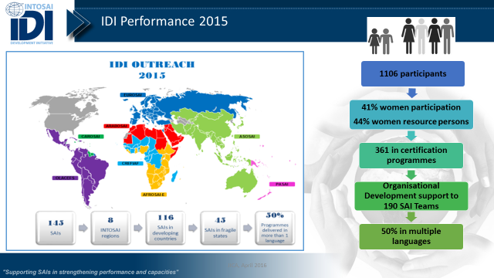
As in previous years, the IDI has achieved strong outreach results in 2015. The programmes delivered in English, Arabic, French and Spanish have had 1106 participants from 145 SAIs. This includes 41% female participation and covers 116 SAIs in developing countries and 45 SAIs from fragile states. Over 48 000 capacity development days have been delivered. Sixteen Capacity Development Programmes have been facilitated during the year. This includes six new programmes in highly relevant areas for capacity development of SAIs like SAI Fighting Corruption; SAI Engaging with Stakeholders; SAI Strategy, Performance Measurement and Reporting; SAI Young Leaders; Auditing Sustainable Development Goals; and Enhancing eLearning Capacity. Other significant programmes offered during the year include the ISSAI (International Standards for Supreme Audit Institutions) Implementation Initiative; IT Audit; IDI- INTOSAI Capacity Building Committee support programme; and Audit of Lending and Borrowing Frameworks Programmes. Bilateral support has been provided to the SAIs of Afghanistan and Somalia. During the year, the IDI continued as the host of the INTOSAI-Donor Secretariat which also received a favourable report from an independent external evaluation of the INTOSAI-Donor Cooperation. The Phase-I of the ISSAI Implementation Initiative has also undergone an independent evaluation with positive conclusions.

B. IDI Knowledge Sharing and stakeholder communication
The IDI is following up on its Knowledge Management Plan by Creating Knowledge Resources for use of External and Internal Stakeholders in the form of Global Public Goods, Organise Knowledge Resources, Disseminate Knowledge Resources and facilitate the application of knowledge resources. The IDI Focus and INTOSAI- Donor Cooperation Newsletters update the global community at a quarterly interval about IDI’s efforts. Regular contributions are made to the INTOSAI journal and other publications for the SAI community. The planning and reporting documents are available to all stakeholders through the IDI website. Knowledge resources are also being disseminated through social media using the IDI Facebook page and IDI YouTube channel.
The 3i Community Portal launched in 2013 continued to provide a platform for information, interaction, learning and community support for ISSAI Implementation. SAI Staff and audit practitioners across the world have benefited from the portal library by downloading the ISSAI Compliance Assessment Tools and ISSAI Implementation Handbooks in Compliance, Performance and Financial Audits that are available in Arabic, English, French and Spanish. The IDI website is currently being upgraded to the IDI Community Portal which will be more interactive and dynamic for the visitors based on the IDI’s experience from the 3i Community Portal. The IDI Community Portal is being test run from August 2016.

C. use of Global Public Goods by stakeholders
Through its capacity development interventions the IDI both contributes to the development of global public goods that are available to the SAI community and other stakeholders and to the dissemination and implementation of the various standards and guidance material developed by INTOSAI and the INTOSAI regions. In 2015, the IDI developed the draft eLearning handbook that has since been finalised. Other Global Public Goods developed include SAI Strategic Management Framework; Draft revised IDI Strategic Management Handbook; 2014 SAI Stocktaking Report; Financial and Compliance Audit Models for Auditing Externally Funded Projects in Agriculture and Food Security Sector; and Guidance on Evaluation of Capacity Development Programmes as part of Guidance Note on Strengthening Evaluations of SAI Interventions.
Besides the development of the above Global Public Goods, the IDI contributed to their dissemination. The ISSAIs developed by PSC, FAS, PAS, CAS - Level 2 and Level 3 & 4 ISSAIs for Financial, Performance and Compliance Audit were disseminated through the 3i Programme, ISSAIs 5500 series on audit of disaster management, SAI PMF and cooperative audits in different INTOSAI regions.
The use of Global Public Goods was also monitored through the 3i Community Portal. A total of 10361 downloads of iCATs (were recorded in 2015. The portal also recorded 22939 downloads of the ISSAI Implementation Handbooks during 2015.

D. Stronger regional bodies, networks and communities
IDI continued to work with the INTOSAI regions and sub-regions to support them in developing the capacities of their member SAIs. In addition to the 201 IDI-PSC (INTOSAI Professional Standards Committee) certified ISSAI facilitators for the English speaking regions and 12 ISSAI mentors available since 2015 to support INTOSAI regions and SAIs in implementing ISSAIs, 56 ISSAI facilitators and 8 mentors are now available in Spanish for OLACEFS. 305 SAI PMF assessors have been trained taking the total trained SAI PMF resource persons to over 800.Following up on the workshop conducted in 2014, a workshop for INTOSAI regions on Strategy, Performance Measurement and Reporting was also conducted in 2015. The regions deliberated a regional strategic management framework and discussed IDI’s new strategic planning model, performance measurement and reporting. All participating regions have sought IDI’s support in strategic plan development, implementation, performance measurement and reporting.
The IDI effectively engaged with INTOSAI regions and other INTOSAI bodies in design, development and delivery of capacity development programmes.

D. Scaled up and more effective support to SAIs
The INTOSAI-Donor Secretariat hosted by the IDI worked towards coordinating effective support to the SAIs. 25(53%) of 47 Concept Notes received and reviewed under the 2013 Global Call for Proposals have been matched with donor funding. The SAI Capacity Development Database has served as a valuable reference database. The Secretariat has also served as a joint focal point with the CBC for INTOSAI Cooperation with the broader development community.

3. IDI Capacity Development Portfolio 2016-2018
During 2016, the IDI is offering 14 Capacity Development Programmes to beneficiaries in the SAI community. One programme is also being offered to the Donor community for better appreciation of the importance and operation of SAIs. These programmes are:
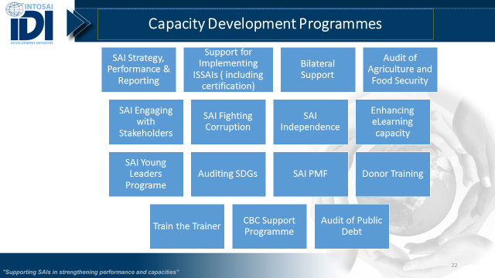
Out of these programmes, eight programmes have been initiated during 2015-2016 and will continue for the remainder of the IDI’s Operational Plan period 2016-2018.
The following is a summary of these programmes:
- ISSAI Implementation Initiative (3i Programme) Phase II
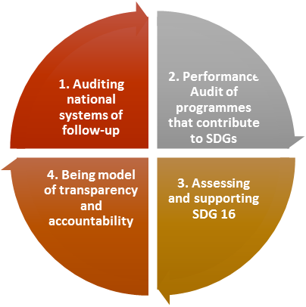
The objective of the programme continues to be the same as in the first phase delivered during 2012-2014 in English speaking regions and currently underway in Spanish, Arabic and French– supporting SAIs in implementing ISSAIs. While the focus will be on developing countries, it is IDI experience that ISSAI implementation is equally an issue in SAIs in developed countries. As such the programme will provide support to SAIs across the INTOSAI community in implementing ISSAIs. Through this programme it is expected that SAIs will define and implement ISSAI implementation strategy based on a good understanding of their current audit practice, stakeholder expectations and ISSAI requirements; SAIs will define audit methodology aligned to ISSAIs and relevant to their context; SAIs will carry out compliance, performance and financial audits compliant with their methodology; SAIs will have staff with professional competence to carry out audits as per standards; and SAIs will have well functioning Quality Assurance function to assure the quality of audit conducted.
- Auditing Sustainable Development Goals
The Sustainable Development Goals (SDGs), which the United Nations Members States jointly committed to in September 2015, provide an ambitious and long-term agenda on a broad range of vital issues. As a contribution to the INTOSAI efforts and SAI efforts in supporting implementation of SDGs the IDI, in cooperation with INTOSAI Knowledge Sharing Committee (KSC), launched this programme in 2015. The programme objective is conducting High quality audits of sustainable development goals by SAIs. The programme envisages four approaches to SDGs. The INTOSAI believes that SAIs can contribute to SDGs by providing advice, through assurance engagements and by conducting performance audits and reviews. The SAIs can also contribute by leading by example in being models of transparency and accountability. INTOSAI also plans to support and encourage its member SAIs in this regard by:
Figure. Four Approaches to SDGs
- Awareness raising and advocacy
- Aggregating results of SAI work done in this area
- Providing methodological support
- SAI Fighting Corruption Programme
The programme envisages achieving the objective of ‘Greater effectiveness of SAIs in fighting corruption’ by supporting participating SAIs in enhancing results in the following three areas:
SAI Leading by example in implementing ISSAI 30- Code of Ethics– Even as SAIs contribute to the fight against corruption in the country, they need to ensure that their own ethical practices are robust. SAIs are expected to undertake a review of their ethical practices based on ISSAI 30.
Audit of Institutional Frameworks for fighting corruption – SAIs will be supported in conducting ISSAI based performance audits of institutional framework for fighting corruption. The tools and guidance developed for providing this support are expected to be based on assessment methodologies development by UNDP’s GAIN programme.
SAI-Stakeholder Platform for fighting corruption – This aspect will be an engagement at the SAI level. Depending on the need and commitment of the SAIs, the IDI will support selected SAIs in setting up or enhancing SAI-stakeholder platform for fighting corruption in the respective countries. This aspect would involve advocacy, dialogue with SAI’s partners in fighting corruption and bringing together of different stakeholders at the country level for the common cause of fighting corruption.
- SAI Independence Programme
Challenges related to independence of SAIs have been explained in the foregoing section. Given the importance of the subject and the needs expressed by SAIs, IDI has launched a pilot programme in this area. The objective of the programme is to Support SAIs in achieving ‘greater independence’. In order to reach this objective, The IDI has envisaged the following implementation framework which will be delivered at global and SAI level:
- Advocate SAI independence
- Guidance on SAI independence
- SAI level support for 3 selected SAIs
- Enhancing eLearning Capacity Programme
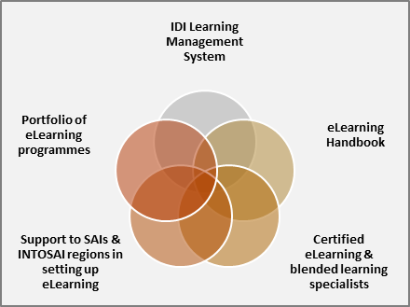
The IDI has been experimenting with eLearning solutions since 2005. Over the years, the IDI has tried web-based training, computer based training, using authoring tools to create e-Learning packages, self-running e-Learning courses, mentor led eLearning courses and blended programmes. After a variety of experiences, the IDI found blended solutions with mentor led eLearning and field audit components to be the best fit for achieving outcomes. This programme will focus on developing IDI’s in-house capacity for eLearning, facilitate the development of regional and SAI capacity, create pools of eLearning specialists and blended learning specialists, define eLearning methodology in an eLearning handbook and create an eclectic eLearning portfolio for the IDI over a period of time. The programme will try to achieve its objectives using a five fold results framework.
Figure. Results framework for Enhancing e Learning Capacity Programme
- SAIs Engaging with Stakeholders Programme
The programme objective is to achieve Greater audit impact through enhanced stakeholder engagement. The expected outputs of the programme include a Research report on SAIs stakeholder engagement; Global Public Goods on SAI Stakeholder engagement; Blended learning courseware developed as per IDI methodology; and SAI teams trained in stakeholder engagement. These outputs are expected to lead to the following outcomes:
- Stakeholder engagement strategies and action plans developed and implemented by participating SAIs
- SAIs initiate new stakeholder interactions
- SAIs report enhanced interaction with key stakeholders
- SAI Young Leaders Programme
SAI leaders make all the difference in the stature, performance & professionalism of a SAI. Leadership is a quality that cuts across every area of the functioning and performance of SAI. In view of the critical significance of leadership, the IDI leadership thought it important to support the development of SAI leadership. The programme would seek to groom SAI young leaders with potential to grow into leaders of tomorrow who show vision, lead their teams, lead their SAI, are effective in their environment, add value and give back to their community. The programme will be a full time programme delivered in English. The programme will be delivered through a variety of engagements that would include face to face training, eLearning, mentoring by in country and international mentors, stakeholder engagement with a wide variety of SAI stakeholders, practical assignments and on the job mentoring.
- Strategy, Performance Measurement & Reporting
The IDI launched its strategic planning programme in 2006, to support SAIs in developing their strategic plans. Subsequently this programme was enlarged to include comprehensive needs assessment guidance. The IDI developed a strategic planning handbook, needs assessment guidance and supported a large number of SAIs in INTOSAI regions in developing their strategic plans. The I-DS also coordinates efforts to develop a SAI PMF that will be considered for adoption as an INTOSAI tool for Performance Measurement of SAIs during INCOSAI 2016. The IDI has initiated work to align its various guidance documents and tools developed over a period and integrate these into a comprehensive strategic management process. The Strategy, Performance Measurement and Reporting programme was launched in 2015 to take care of the above mentioned needs to develop a comprehensive Strategic Management Framework for SAIs and INTOSAI regions and support the SAIs and regions in their strategic planning, performance measurement and reporting.
- SAI Performance measurement Framework
The SAI Performance Measurement Framework (SAI PMF) is a global public good of INTOSAI that provides SAIs with a framework for voluntary assessment of their performance against the International Standards for Supreme Audit Institutions (ISSAIs) and other established international good practices. During the pilot phase 2012-15, the global roll-out of SAI PMF has been a partnership between INTOSAI Committees, Regions, and IDI, coordinated by the I-DS, with financial support from the INTOSAI-Donor Cooperation, and in-kind support from members of the INTOSAI and Donor Community. Post 2015, the CBC takes the role as being the custodian of SAI PMF and has governance lead on all the support related roles. The IDI Board has approved the IDI with the responsibility for facilitating conduct of SAI PMF assessments and usage of results. The governance lead on conduct of individual SAI PMF assessments is placed with the SAIs, recognizing the key principle of SAI ownership to the individual assessments. The IDI hold the primary implementation responsibility for activities and tasks related to SAI PMF. Includes the role as global coordinator, training body, support function, quality assurance function and knowledge centre for SAI PMF. This department would also take on the primary responsibility in connection to facilitating conduct of SAI PMF assessments and the usage of assessment results, through cooperation with the INTOSAI regions in developing regional strategies for SAI PMF and programmes.

4. Cooperation with INTOSAI KSC
- Cooperation with the INTOSAI KSC Chair
During 2015-16, IDI and INTOSAI KSC Chair have had wide ranging cooperation to support the capacity development of SAIs. These include the following:

Development of KSC - IDI Knowledge Sharing Portal
The Knowledge Sharing Portal to host INTOSAI communities of practice has been jointly developed and launched by the INTOSAI KSC Chair and the IDI. The IDI has supported KSC by designing and developing the community portal. The portal is hosted by the IDI, which is also providing the technical support. The contents of the portal and the communities of practice will be managed by KSC Chair. The portal currently hosts communities of practice on Auditing SDGs, Common Forum, INTOSAI Auditor Certification, SAI Young Leaders Programme, ASOSAI Regional Research Project etc. Support has also been provided to the CBC-INTOSAINT and EUROSAI Task Force on Audit and Ethics. The portal has several other interactive features like, News, Calendar, Library, Blogs, Videos, Chats etc.
The Portal is available for use by all INTOSAI/ Regional bodies and they may contact SAI India for getting access/support in this regard.

Auditing Sustainable Development Goals
Following the strategic direction of INTOSAI, the IDI and KSC are cooperating to design, develop and deliver this programme. The programme details have been provided in the previous section. A resource team from the INTOSAI Knowledge Sharing Committee (KSC), INTOSAI Working Group on Environment Audit (chaired by Indonesia), PASAI Secretariat, Brazil, United Arab Emirates, United States of America, UNDESA and the IDI met at UN Headquarters in New York July 27-29, 2016, to agree on the emphasis and structure of guidance associated with auditing preparedness for implementation of SDGs. The team agreed to take a “whole of government” approach and focus attention on two goals (Goals 16 and 5), which are a part of the High-Level Political Forum (HLFP) theme, “Empowering people.” The guidance will be discussed as part of Theme I at the upcoming INCOSAI 2016 in December.

INTOSAI Common Forum of Technical Experts
The IDI is an active member of the common forum of technical experts set up by the chairs of INTOSAI’s Professional Standards Committee, Capacity Building Committee and Knowledge Sharing Committee to address standard-setting issues.
- Cooperation with Working Groups

Working Group on IT Audit
The IDI is cooperating with the WGITA in a global capacity development programme in IT Audit. The programme aims to promote IT audit systems and practices in line with INTOSAI standards and best practices; address capacity building needs in the area of IT auditing conducted by the SAIs of developing countries and disseminate application of professional guidance. 38 out of 40 SAIs (40 IT Audit teams) have completed the audits during 2015.

Working Group on Public Debt
The IDI’s transregional programme on Auditing Lending and Borrowing Frameworks focuses on strengthening the SAIs’ audit capabilities in assessing the legal and administrative frameworks in the borrowing as well as lending sovereign functions. WGPD is a key partner for this programme. The programme is being run simultaneously in English and Spanish and involves selected SAIs in the developing countries. The programme involves 13 and 9 SAIs from the INTOSAI English and Spanish regions respectively representing both the lending and borrowing countries. 22 out of 24 audit teams have conducted the audits and the results are currently being consolidated in a compendium.

Working Group on Environment Audit
The IDI is cooperating with the WGEA in the Programme on ISSAI based Cooperative Audit of Disaster Management for the SAIs in ASOSAI region. 57 participants from 19 SAIs are participating in this programme.

Working Group on Value and Benefits for SAIs
The INTOSAI-Donor Secretariat continued coordinating the development and refinement of the SAI PMF. Over 25 SAIs are currently in different stages of assessment. The framework being developed under the aegis of the WGVBS will be presented at INCOSAI 2016 for ratification.

Working Group on Fight against Corruption and Money Laundering
The WGFAML is a key partner for the recently launched programme on SAIs Fighting Corruption that has been explained in the previous section. The Guidance for the programme has been drafted and will be shortly shared with the WGFAML and other stakeholders for their comments.

Other issues

The IDI Governance Review
The IDI Governance Review was initiated in 2014 and Frank Grogan Research and Consultancy Limited presented the Governance Review Report to the IDI Board in its meeting in March 2015. The IDI Board decided in principle to implement a number of the recommendations and established a Board Task Force on Governance with a mandate to assess how the Board could use the findings and recommendation from the report to enhance the IDI governance structure. The recommendations of the Governance Review and the Task Force have been accepted by the IDI Board resulting in the following:
- Total members increased to 10 with no observers
- Nomination Committee to recomend appointments to the Board
- Better representation to developing countries
- Detailed Rules of Procedure for effective performance
- Assessment of the Board’s performance

For further information please visit www.idi.no ; 3i Community Portal at www.idicommunity.org; for requests for IDI Newsletter and INTOSAI-Donor Cooperation Newsletters please send a request to idi@idi.no. IDI also provides regular updates to the International Journal of Government Auditing.

