
INTOSAI
International Organization of Supreme Audit Institutions



Working Group on Program Evaluation – INTOSAI
PROGRESS REPORT
Mexico, 7-9 September 2015
During the 8th KSC Steering Committee Meeting in Mexico on 7-9 September 2016, the Endorsement Version of INTOSAI GOV 9400 will be presented by the Working Group on Programme Evaluation for approval.
On approval of the Endorsement Version during the KSC Steering Committee meeting, the Working Group will present the final endorsement version at the INCOSAI Congress in December 2016, for final approval.

- The INTOSAI working group on Programme evaluation (EWG) was created in 1992. The purpose of the group is to help SAIs which practice evaluation or wish to do so by providing them with doctrinal texts, methodological tools and practical recommendations to implement this specific approach, which is different from other forms of control and audit. For this reason, the working group is placed under the authority of the KSC.

- This group is currently made up of 22 SAIs. It has been chaired by the French Cour des comptes since its inception. Brazil has been given observer status in its capacity as Chairman of the Professional Standards for Performance Audit Subcommittee (PAS), which is the form of control that is most similar to evaluation.

- The different congresses of INCOSAI held since 1992 have successively observed the following advancements in this approach:
- 1992 (14th INCOSAI Congress in Washington): creation of the working group
- 1995 (15th INCOSAI Congress in Cairo): request for the preparation of a methodological guide
- 1998 (16th INCOSAI Congress in Seoul): progress report on the methods and practices in force at the SAIs
- 2004 (18th INCOSAI Congress in Budapest): introductory report on fundamental concepts with some examples
- 2007 (19th INCOSAI Congress in Mexico City): working group on program evaluation placed under the authority of the Knowledge Sharing Committee (KSC)
- 2010 (20th INCOSAI Congress in Johannesburg): validation of the “Program evaluation for SAIs- A primer” report, proposed by the working group and validated by the KSC
- 2013 (20th INCOSAI Congress in Beijing): The proposal of an amended version of the preparatory document was presented at the Congress in Beijing in October 2013.

- An online working space has been dedicated to the evaluation of public policies since November 2010.

- A questionnaire to collect best practices and concrete information on evaluation methodologies at the SAIs (prepared by a sub-working group comprised of 5 SAIs) was approved by the group in Paris in May 2011 and sent to INTOSAI's 191 SAIs. The results of the questionnaire (44 SAIs participated) were presented at the 4th KSC meeting in Luxemburg in 2012.

- At its 2012 meeting in Paris, the group decided to go on in order to further refine the concepts of evaluation and to identify instructive examples for the SAIs, and to prepare a detailed methodological guide offering a broad range of resources and recommendations for completing evaluations.

- Prior to this meeting, the PAS was made aware of the group's work at the PAS meeting in Ottawa on May 28 and 29, 2013. It was proposed to the PAS, which accepted, that the working group would continuously coordinate with its own work on the preparation of Level 300 and Level 3000 ISSAIs on the performance audit.

- At the meeting of the working group on June 25, 2013, the working group discussed the links between the professional standards of the performance audit and the planned evaluation methodology guide. It also amended and validated the preparatory working document for the guide distributed in April 2013. EWG validated the following criteria constituting an evaluation:
    - Possibility of calling into question the objectives defined at the legislative level
    - Examination of the relationship of causality between public action and its impact (use of the impact model)
    - Systematic integration of stakeholders in the project (support group, interviews, etc.).
    - Use of scientific research methods with multi-disciplinary teams.
    - Publication of the report and transparent description of the methods used.

- The working group then began the detailed preparation of the methodological guidelines. A detailed version was sent to all the EWG’s members in July 2014.
- At the June 2015 EWG meeting in Paris, it was decided that the guide would take the form of an INTOSAI GOV. Between June and October 2015, the project proposal was drafted in order to get the KSC’s approval in October 2015. The Steering Committee of the KSC finally approved the exposure draft on February 17th, 2016, and it was posted on www.issai.org. The exposure period lasted from February 17th to May 14th 2016. During this period, 149 comments were received, including a large number from international organizations such as the UN, the OECD or the World Bank. These comments were analyzed carefully section by section in order to insure the consistency of the document.
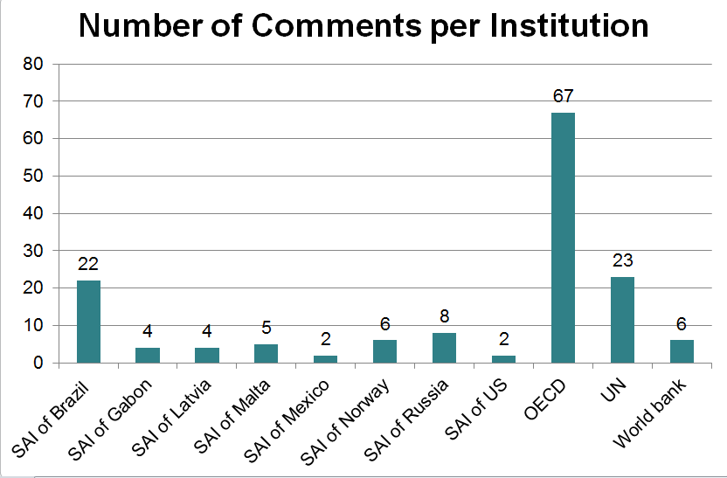

- Between May 14th and May 31st 2016, the comments were analysed one by one and taken into account by the Chair SAI. In total, two thirds of these comments were at least partially accepted or agreed on.
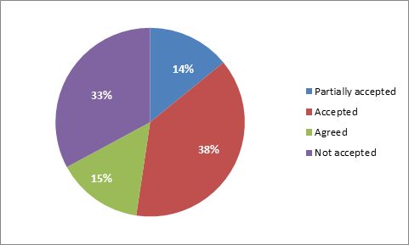

- The Chair then sent the resulting document to all members of EWG, in order for them to be able to express any further comments and prepare the June 20th meeting in Paris. The French SAI posted the comments and the responses to these comments on www.issai.org, in accordance with the due process for INTOSAI Professional Standards. It was decided to adopt the expression of public policy evaluation instead of program evaluation.
- At the June 20th, 2016 meeting in Paris, the group agreed on several minor changes to be brought to the endorsement version of the document. These changes were added to the text between June 20th and July 1st, and the INTOSAI GOV 9400 was then sent back to the members of the group for final approval.
- In July and August 2016, the document was translated in the five languages of INTOSAI, as well as the executive summary.
- The document, primarily intended to be a methodological guide of the different forms of evaluations conducted by member countries, focuses on the evaluation of public policies. These Guidelines on Evaluation of Public Policies provide the most relevant framework possible, given the technical development of methods and the members now increasing experience. Each SAI can use them, taking into account local circumstances, either for carrying out/performing evaluation, for assessing evaluation performed by others or for encouraging and supporting actors willing to develop this activity in accordance with common practises.

Belgium, Chile, Costa Rica, El Salvador, Finland, France, Gabon, Georgia, Germany, Hungary, Kenya, Republic of Korea, Libya, Lithuania, Mexico, Morocco, Pakistan, Papua New Guinea, the Philippines, Poland, Switzerland, United States.

