WG on Public Debt’s Progress Report
Guide to project the Slides Presentation

Text | Slide
Dear colleagues,  I am pleased to present, on behalf of Mr. Juan M. Portal, Auditor General of Mexico and Chairman of the Working Group on Public Debt, the report of this INTOSAI entity’s activities since the 6th meeting of the KSC Steering Committee in Cairo, in October 2014. | 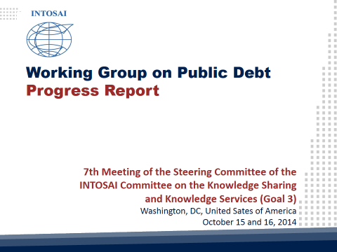
Our annual meeting took place from July 22 to 24, 2015 in Livingstone, Zambia, with the participation of 36 delegates representing 13 member SAIs, namely: Argentina, Austria, Brazil, Chile, China, Finland, India, Mexico, Portugal, Ukraine, South Korea, United States of America, and Zambia. | 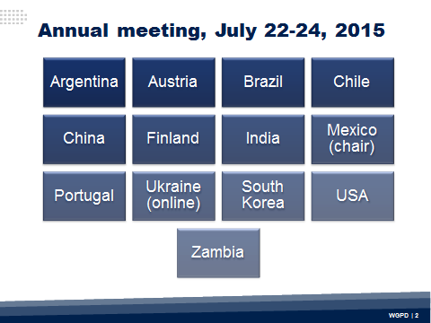
Representatives from the INTOSAI Development Initiative (IDI), the United Nations Conference on Trade and Development (UNCTAD), the Secretariat of the Organization of English-speaking African Supreme Audit Institutions (AFROSAI-E), and the German Agency of International Cooperation (GIZ), also attended the meeting. | 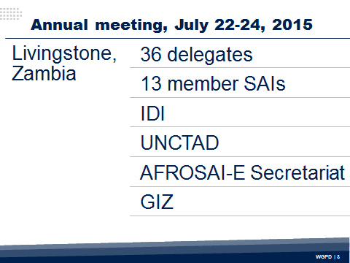
I would like to highlight the work carried out in relation to the ISSAIs Harmonization Project. Considering the Professional Standards Committee’s revision of the ISSAI Framework, during the last years the Working Group has also revised the existing professional standards on public debt to ensure its validity and relevance. | 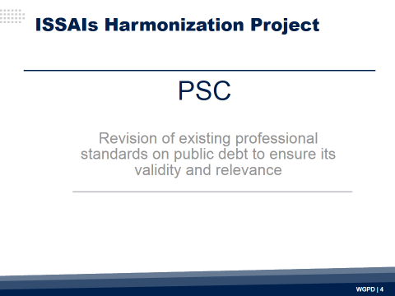
Five key criteria were considered during this revision: usefulness, updating required, potential harmonization with other Working Group’s products, alignment to other standards in the ISSAI Framework, and harmonization of the general ISSAI terminology, considering particularly the recently revision by the PSC of ISSAIs 100 to 400. | 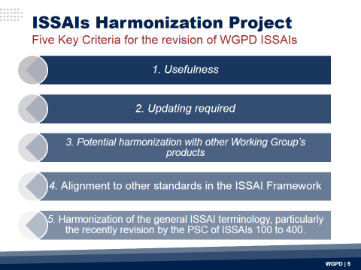
This effort has concluded. Following the ISSAI Due Process, the Working Group members approved the revised version of the following standards:  - ISSAI 5410 “Guidance for Planning and Conducting an Audit of Internal Controls of Public Debt”.  - ISSAI 5421 “Guidance on Definition and Disclosure of Public Debt”.  - ISSAI 5422 “An Exercise of Reference Terms to Carry out Performance Audit of Public Debt”.  - ISSAI 5430 “Fiscal Exposures: Implications for Debt Management and the Role of SAIs”. | 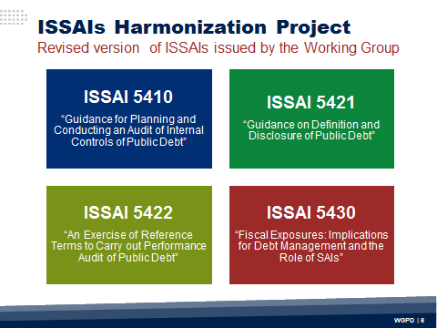
Hereby I kindly ask the members of the KSC Steering Committee not only to endorse the referred revised ISSAIs, but also to approve the withdrawal from the INTOSAI Standards Framework of the ISSAI 5420 “Public Debt: Management and Fiscal Vulnerability: Potential Roles for SAIs”.  Due to the relatively recent issuing of the ISSAI 5411 “Debt Indicators”, this standard was not subject to this revision process, but will be included in the next one. In this regard, it is worth mentioning that Goal 3 Working Groups are now responsible for the periodic revision of ISSAIs with a frequency of at least every five years, so the Working Group will keep the KSC Steering Committee informed. | 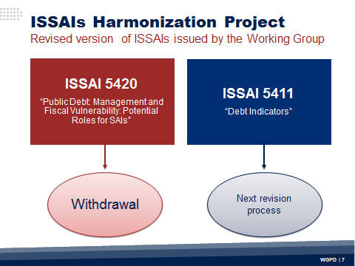
Other relevant project of the Working Group is based on its Strategic Plan’s objectives to “prepare and publish guidelines and other material to be used by SAIs in order to encourage the proper reporting and sound management of public debt”, “to identify key issues for the development of responsibilities and procedures for auditing and evaluating public debt commitments”, and “to prepare papers examining matters on public debt definition, reporting and assessment”. That is why a Working Group’s permanent agenda item refers to the development of investigation themes. | 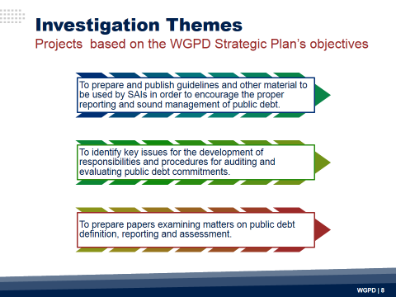
In this sense, I would like to mention the progress made regarding two research projects: "Evaluation of Information Systems related to Public Debt Management" and "Public Debt Management Office". Both documents have been analyzed by the members of the Working Group and are subject to the procedures defined in the Due Process.  The research on the “Evaluation of Information Systems related to Public Debt Management”, was originated during our meeting in 2009, held in Kiev, as part of the efforts to encourage appropriate accountability and sound management of debt. This document was approved in May 2013, by the Chair of the KSC Steering Committee, and subsequently by the Professional Standards Committee, which classified it as possible ISSAI 5450. From 1 July to 1 October 2013, it was published on the Website of the ISSAI Framework as exposure version for comments by the INTOSAI community. | 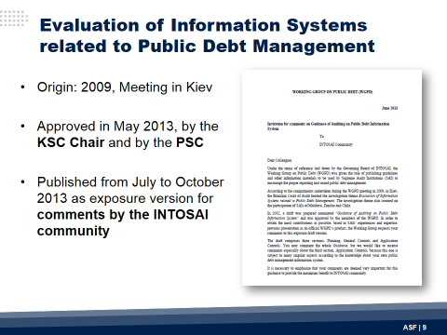
Furthermore, I want to emphasize that this guideline has been implemented as a reference for the development of the "Coordinated Parallel Audit of Information Systems for Public Debt Management" initiative. Due to the nature of the comments received from the INTOSAI community during the exposure period, and considering the lessons learned during the coordinated parallel audit, the revised version of this research was subject to a re-exposure period, in accordance with Due Process. Therefore, ISSAI 5450 could be presented as a draft international standard during the XXII INCOSAI in 2016, for final approval. | 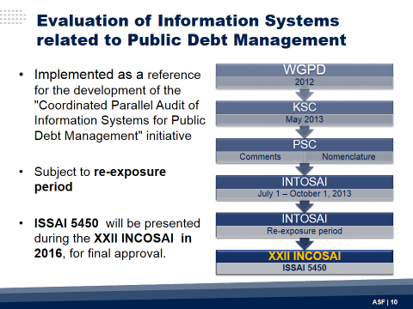
The second ongoing research, "Public Debt Management Office", was originated in the 2008 meeting, held in Nadi, Fiji. This is the first INTOSAI Guideline for Good Governance (INTOSAI GOV) developed by the Working Group; its goal is to provide guidance, from the auditors’ perspective, for the establishment of an effective debt management office. The draft was shared to the Chair of the Knowledge Sharing Committee, whose feedback has been taken into account. Since the document has been approved by the members of the Working Group, hereby we ask for the KSC Steering Committee’s endorsement, so it could be presented before the Professional Standards Committee for classification and approval to be exposed for comments by the community of SAIs. This INTOSAI GOV is expected to comply with the ISSAI Due Process in 2016, so that it could be presented for final approval during the next INCOSAI. | 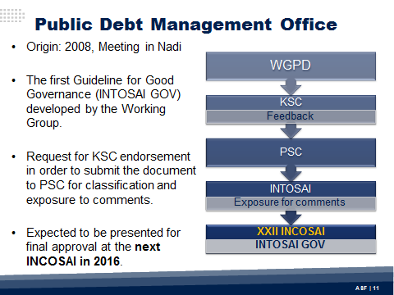
I will now address the previously mentioned initiative “Concept Framework of Coordinated Parallel Audit of Public Debt Management Information Systems”. Its objective is to assess the appropriate implementation of management and control process in relation to the efficiency of Public Debt Management National Information Systems. Twelve members SAIs are involved in this initiative with a two-year work plan (2014-2015). To date, three meetings have been held (Ukraine, Moldova and Georgia), to coordinate the execution of the parallel audit and the study of information systems to manage public debt at national level. As a reference, the initiative is based not only on the Guidance for Conducting a Public Debt Audit, developed by the IDI in collaboration with the Working Group, but also on the draft ISSAI 5450 “Guidance of Auditing on Public Debt Information Systems”. The Joint Parallel Audit Report of this initiative will be disseminated by the WGPD Chair in December 2015.  This project supports the implementation of our Strategic Plan’s first goal: “Capacity building and enhancing SAI expertise”. | 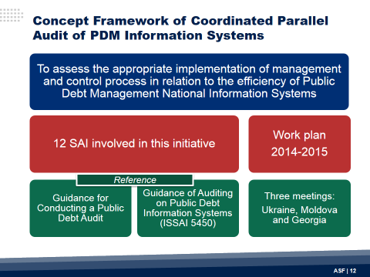
In this regard, other key initiative to build professional capacities tailored to the needs of the community of SAIs, is the public debt-related trans-regional capacity building programs developed by the IDI with the Working Group’s support.  In this regard, it’s worth mentioning IDI’s work from 2008 to 2011 to develop and implement the Trans-regional Programme on Public Debt Management Audit, which strengthened the institutional capacities of 29 participating SAIs from 5 regional working groups in relation to the subject matter, and also helped promoting the sound public debt management and auditing. One of the outcomes of this initiative is the guide “Auditing Public Debt Management”, previously mentioned, which will also be subject to a revision process due to the necessity to keep it up to date, as it provides practical audit procedures, questions and tools to assist auditors in conducting audits on nine specific public debt management topics. | 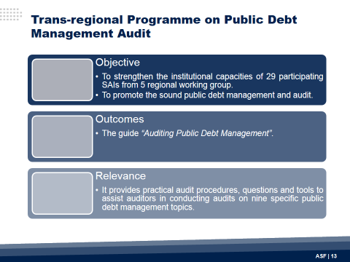
Due to the impact and results of this program, as well as the needs and requirements for capacity building identified within the INTOSAI community, the agreement for collaboration between the IDI and the Working Group was renewed a couple of years ago. As a result, IDI designed and launched a Trans-regional Programme on Strengthening Public Oversight and Audit of Sovereign Lending and Borrowing Frameworks. | 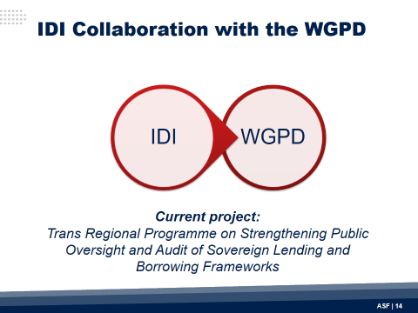
The objective of this capacity building program is to strengthen the professional and institutional capacity of participating SAIs in conducting in-depth and effective audit of lending and borrowing frameworks, which in turn would result in influencing effective sovereign lending and borrowing practices. | 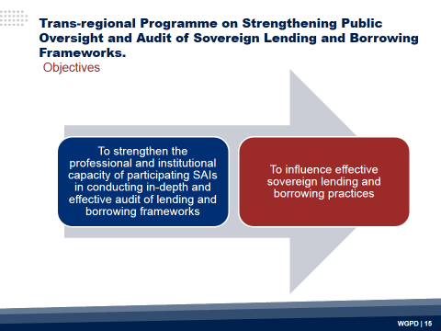
This IDI’s initiative is a joint effort with the Working Group on Public Debt and UNCTAD. Until now, working meetings in different INTOSAI regions have been held, including OLACEFS and ASOSAI, with the participation of senior management of the SAIs to ensure proper understanding of the requirements, relevance and results of the program, and also the involvement of audit staff to conduct the corresponding activities. The WGPD will continue collaborating and strengthening the working relationship with the IDI. | 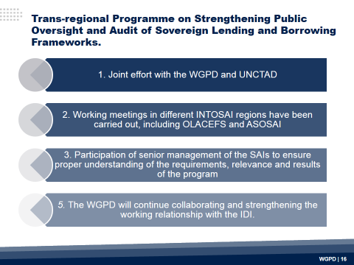
To promote capacity building and to improve the expertise of SAIs about public debt auditing, the exchange of experiences and knowledge within the Working Group is promoted. The WG website and physical meetings aim to constitute virtual and physical spaces to present best practices, to discuss the challenges faced and to exchange views on innovative methodologies, new developments, and issues of mutual concern related to the audit of public debt. Therefore, the updating of the Working Group website is an activity looked after by its membership. | 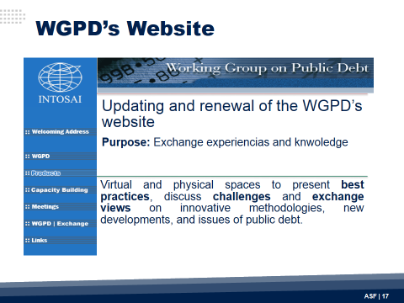
In addition, following the INTOSAI’s motto, the Working Group has maintained a collaborative relationship with relevant partners, including the World Bank, UNITAR, UNCTAD, the Inter-American Development Bank, and more recently the OECD, by implementing a virtual platform to share knowledge. | 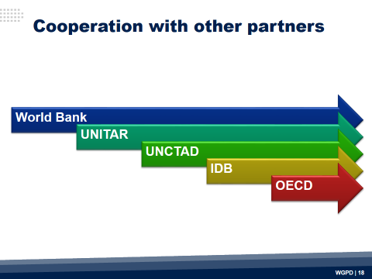
To be recognized as the leading forum for its excellence in technical contributions, and capacity building projects related to public debt auditing, as well as the relevance of its publications, the Working Group members have agreed to revise its Strategic Plan. This task will be conducted taking into account not only the new developments and challenges faced by the INTOSAI, but also the Organization’s strategic planning for the period 2017-2022. Virtual discussion fora and the results of a survey on the impact of the Working Group within the INTOSAI community, will also be useful inputs in this process. | 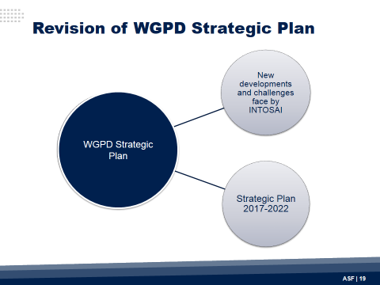
Last but not least, after more than twenty years as Chair of the Working Group on Public Debt, the SAI of Mexico will call for nominations to occupy this honorable position. Valuable outcomes have been achieved during these two decades thanks to the active participation, productivity and commitment of all member SAIs of the Working Group, and to the support provided by the INTOSAI authorities, including the KSC Steering Committee.  In this regard, the last meeting to be chaired by the SAI of Mexico will be the one to be hosted in 2016 by the SAI of China, which kindly volunteered to organize our annual encounter during the first semester. Thus, the XXII INCOSAI will be the ideal setting to hand over the WGPD Chair. I am confident that this renewal will bring new perspectives to continue effectively addressing the Working Group’s agenda, considering its relevant contribution to the INTOSAI community. | 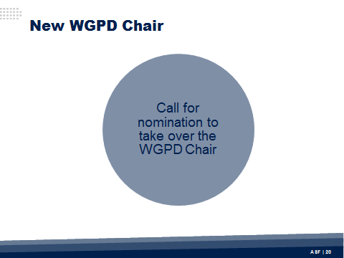
Ladies and gentlemen, thank you very much. | 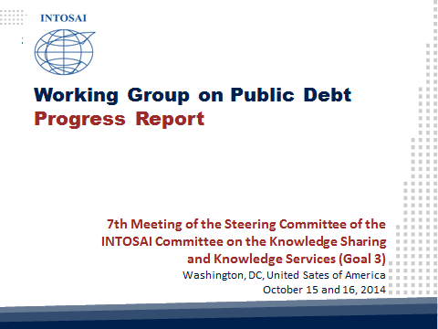
 | 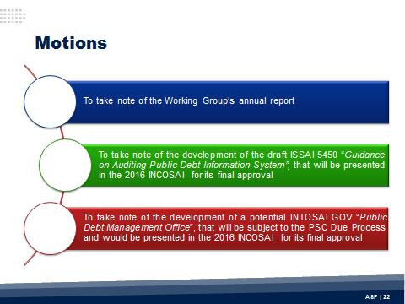
 | 