7th Meeting of the Steering Committee of the

INTOSAI Committee on the Knowledge Sharing and Knowledge Services (Goal 3)

Washington, DC., United States of America

October 15 & 16, 2015

Annual Report of the INTOSAI Working Group on the

Value and Benefits of SAIs (WGVBS)

Guide to project the Slides Presentation

Dear colleagues,  I am pleased to present you, on behalf of Mr. Juan M. Portal, Auditor General of Mexico and Chairman of the INTOSAI Working Group on the Value and Benefits of SAIs (WGVBS), the activities carried out by the Working Group since the last meeting of the KSC Steering Committee held in Cairo, in October 2014. | 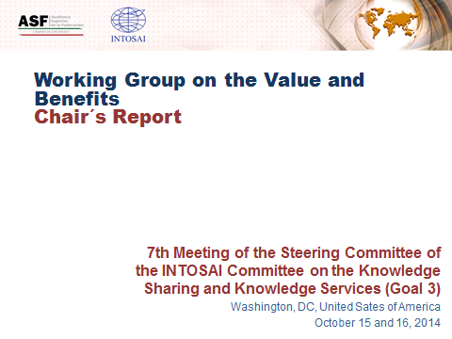
To date, the Working Group’s membership comprises 23 SAIs, after the decision of SAIs of Canada and India, to whom we convey our deepest appreciation, to conclude its valuable participation in this INTOSAI working entity. | 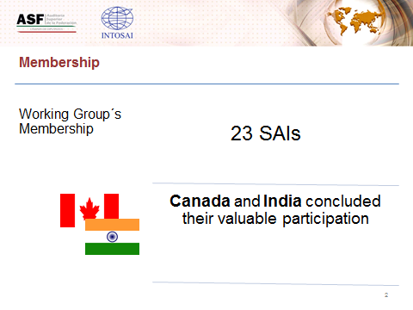
During its existence, the WGVBS has counted on the collaboration of the United Nations Department of Economic and Social Affairs (UNDESA), the International Budget Partnership (IBP), the Inter-American Development Bank (IADB), the Global Initiative on Fiscal Transparency (GIFT), and the World Bank. More recently, our Working Group has established communication towards a formal exchange of information with external parties interested in the role of SAIs to engage with citizens, namely the Organisation for Economic Co-operation and Development (OECD), the German Agency for International Cooperation (GIZ), and the Civil Association for Equity and Justice (ACIJ, a Latin American NGO). | 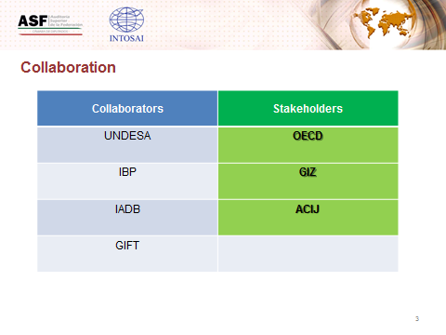
During this year, the Working Group has focused its efforts on concrete projects, as agreed by the members to work towards practical outcomes, rather than theoretical ones, that could be useful for the SAI community.  A task team coordinated by the INTOSAI Development Initiative has continued its work, according to the timetable approved by the Working Group in September 2014, so as to develop a single, global Performance Measurement Framework for assessing and monitoring SAIs’ performance (SAI Performance Measurement Framework – SAI PMF). | 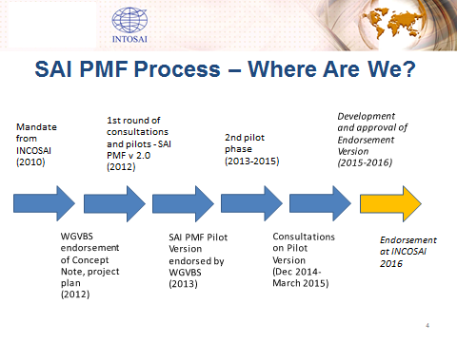
The SAI PMF has been subject to pilot tests in diverse INTOSAI regions in order to learn from the relevant SAIs’ experience, and to calibrate the tool. | 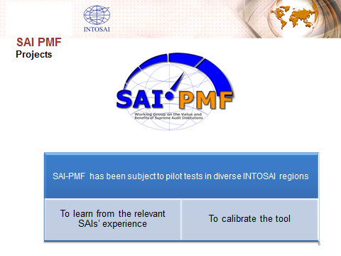
In this regard, the target of 20 pilot assessments has been reached. The second, larger pilot phase for SAI PMF ran from July 2013 until May 2015. | 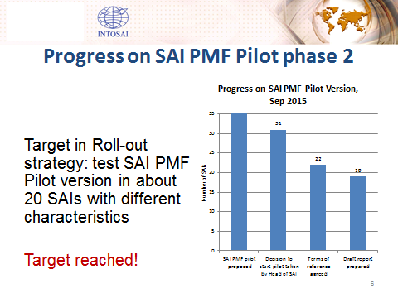
The objectives of the piloting has been to enable extensive testing of the framework in a number of diverse environments, as well as analysis of the resulting indicator scores to ensure the scoring system is properly calibrated. In addition, a 90-day consultation on the SAI PMF pilot version ran from December 19, 2014, until March 31, 2015, for the INTOSAI community to have a chance to provide feedback. The comments received were posted on the IDI Website on April 17, 2015. | 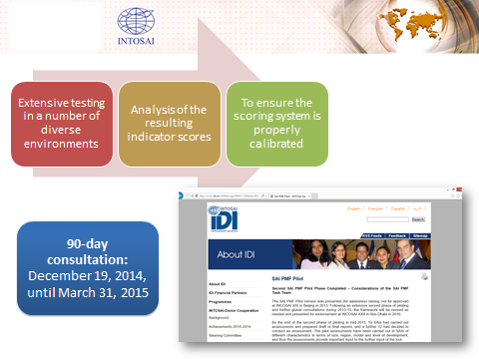
Following the closing of the consultation period, the SAI PMF Task Team prepared a paper on considerations regarding consultation comments and experiences from pilots. The paper and responses to the consultations comments were posted on the IDI website on September 28, 2015.  The experiences to date show that SAIs find the SAI PMF useful for holistic assessments of SAI performance, although a number of suggestions for improvement of the tool were received. | 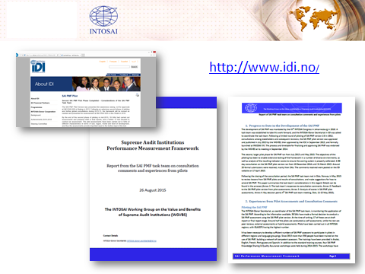
The Task Team also presented before the WGVBS its recommendations on the further development of SAI PMF for its presentation before and endorsement at the XXII INCOSAI. To this end, the Working Group has endorsed the Task Team’s recommendations, including suggested amendments to the timetable for finalizing and approving SAI PMF. The amendments include that a revised draft version will be presented to the Working Group in February 2016 for comment, and an additional, focused testing period in early 2016. Regarding this project, hereby we kindly ask the KSC Steering Committee to also endorse the recommendations and the suggested amendments to the timetable for the presentation of SAI PMF before the next INCOSAI. | 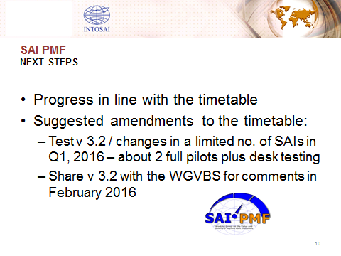
In addition, we also ask the KSC Steering Committee to take note on the considerations shared by the Task Team for the maintenance of SAI PMF after 2016, including the need for ownership by an INTOSAI committee and provision of dedicated resources for training, updating the framework and developing guidance. | 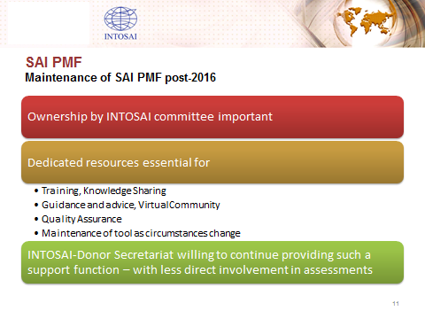
Another key project of the Working Group refers to the development of a Guideline on Effective Practices of Cooperation between SAIs, the Legislature, the Judiciary and the Executive that focuses on the SAIs’ ability to promote accountability that leads to administrative and/or corrective sanctions being imposed. This second draft of the document, coordinated by the SAI of Jamaica, is currently being subject to a new revision process so as to enrich its contents, including examples of good practices as an annex of the guideline. An enhanced version of the document should be available at the end of October, 2015, for the Working Group to be in a position to subject the document to the INTOSAI Due Process so that it could be presented to the INTOSAI Community at the XXII INCOSAI. | 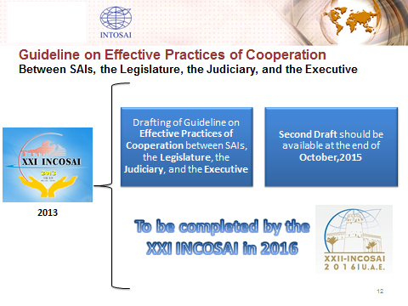
As you might remember, last year a “Forum of Jurisdictional SAIs Network of General Prosecutors” was created as a Working Group’s sub-entity. It is a space for reflection, collaboration and exchange of good practices particularly for jurisdictional SAIs. Its purpose is to demonstrate the value and benefits of SAIs with this institutional model, considering that, since these SAIs have the mandate to impose sanctions before irregular and inefficient use of public funds, they contribute to good governance and accountability. | 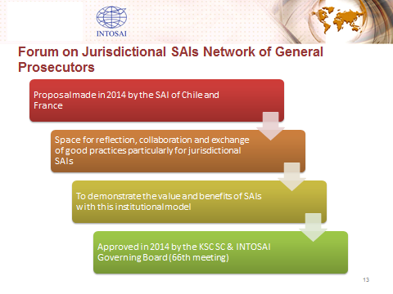
To this end, the forum members meet virtually to follow up their activities, which include the development of a tool to assess the performance and value of jurisdictional SAIs, as well as the allocation, among its members, of investigation themes on the subject matter. The entities participating in this forum are the SAIs of Brazil, Chile, France, Italy, Morocco, Peru, Portugal, Spain, Tunisia, and Turkey. | 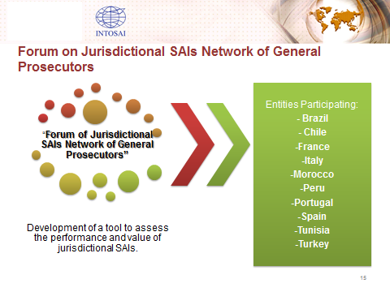
Other relevant project within the WGVBS is conducted by a Task Force made up by the SAIs of Mexico, Namibia and South Africa. Its mission is to identify, through a survey applied only to the Working Group members as a sample of the INTOSAI community, the activities that SAIs are developing with regard to the principles of ISSAI 12, and, if applicable, knowing the reason why some principles are not yet implemented, in order to evaluate existing challenges or obstacles.  Although the task was originally focused on the principles that have been not yet implemented in each SAI, the survey was also useful to identify good practices and lessons learned. | 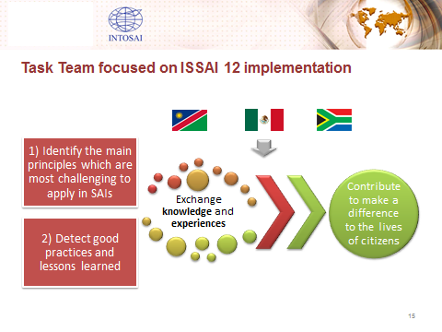
To outline more reliable conclusions on the matter, the Working Group members that did not participate in the survey, were asked to do so in order to count on the perspective of the whole membership of the Working Group. This WG Chair will keep the KSC Steering Committee informed on this project outcomes. | 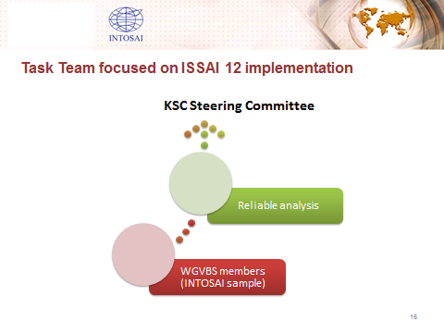
Since its creation in November 2007, the Working Group’s mandate has been evolving according to the needs, challenges and opportunities identified within the INTOSAI community. Originally this entity was established to develop a framework and measurement tools for defining the value and benefits of SAIs. | 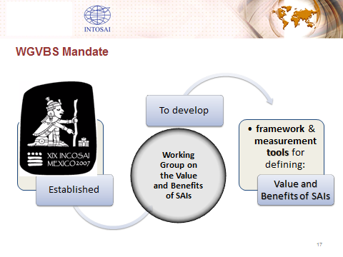
In 2010, it was resolved that this Working Group should develop instruments and tools for communicating and promoting the value and benefits of SAIs. Since then, this entity has contributed to raise the awareness, within the INTOSAI community and before relevant stakeholders, on the impact of supreme auditing and its value to make a difference in the lives of citizens by contributing to trust, efficiency, and effectiveness. | 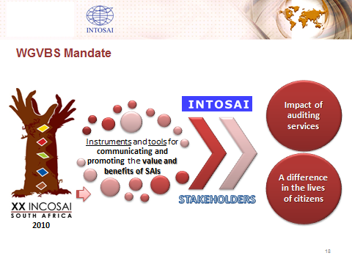
Additionally, discussions have been held on the importance for SAIs to identify and manage their own risks as well as those of the public sector. The Working Group will prepare a draft to expound the main elements that SAIs should take into account to identify both (1) key national risks, and (2) its own internal functioning risks. As for the former, the SAI of Mexico will work with the US GAO, and as to the latter, the WG Chair’s coordination will be with the National Audit Office of China. | 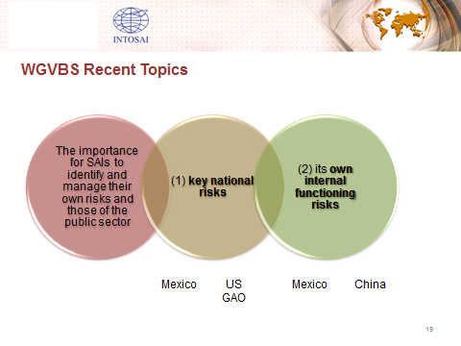
Regarding other scope of activities, and as resolved by the XXI INCOSAI in 2013, the Working Group also looks after the promotion and communication of the value and benefits of INTOSAI tools, including the SAIs’ Information Database, the SAI Capacity Development Database, the Self-Assessment on Integrity (IntoSAINT), the Collaboration Tool, the INTOSAI Online Glossary, and the Experts Database. That is why the WGVBS members follow-up the implementation and/or updating of different INTOSAI tools. | 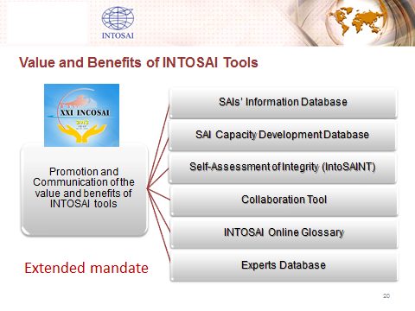
All these initiatives have been addressed through virtual and in-person meetings. In this regard, our annual meeting was held from September 14 to 16, 2015 in Nanjing, People’s Republic of China, with the participation of 27 delegates representing 12 member SAIs, namely: Austria, Cameroon, China, France, Germany, Iraq, Mexico, Namibia, Peru, South Africa, Tanzania, and the United States of America, and with representatives of the INTOSAI Development Initiative.  The Working Group’s meeting in 2016 will be organized by the SAI of Tanzania. The specific dates (potentially in September) will be announced in due time by the WGVBS Chair. | 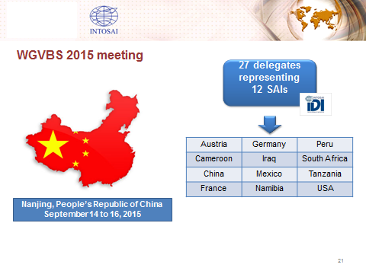
Before concluding my report, I consider convenient emphasizing the importance of the activities to be conducted in 2016, which is our last stretch for the presentation of relevant deliverables before the XXII INTOSAI Congress. We will maintain constant communication with the KSC Chair bearing in mind the different steps ahead and collaboration required, as established by the Due Process. Furthermore, in addition to the products already addressed, the Working Group will be aware on the updating of the INTOSAI Strategic Plan for the period 2017-2022, so as to be prepared to align, if necessary, the future approach of the WGVBS activities to effectively promote and communicate the value and benefit of SAIs. | 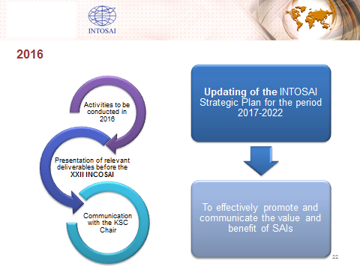
Last but not least, I would like to acknowledge the member SAIs’ commitment and tight collaboration, as well as the support provided by the KSC Steering Committee to fulfill our mandate.  On the screen you will see the motions presented before the members of the KSC Steering Committee for your approval:  1. To take note of the Working Group’s annual report.  2. To endorse the SAI PMF Task Team’s recommendations, including suggested amendments to the timetable for finalizing and approving, at the XXII INCOSAI in 2016, the SAI Performance Measurement Framework. In addition, to take note on the considerations shared by the Task Team for the maintenance of SAI PMF after 2016, including the need for ownership by an INTOSAI committee and provision of dedicated resources for training, updating the framework and developing guidance. | 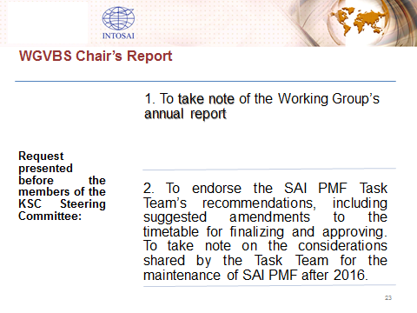
3. To draw the attention of INTOSAI to the issue of citizen participation, acknowledging the relevance that it has gained and the challenges and risks that it entails. There seems to be natural areas, within the auditing process, that are most likely to accommodate citizens participation such as audit planning and dissemination of audit reports.  - INTOSAI should be aware on the need to assess the quality of information of its different databases and tools, as well as the usability of them, so as to not allocate resources in activities which are not producing the desired outcomes and impact. | 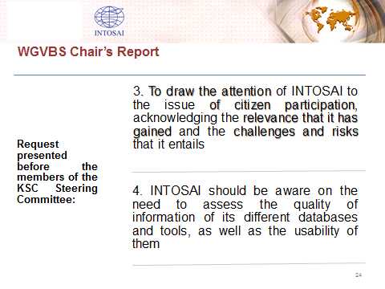
Ladies and gentlemen, thank you very much. | 