Contents
- Introduction
- Key Developments in 2013-2014
- IDI Performance in 2013-2014
- Capacity Development Initiatives in the new Strategic Plan period
- Knowledge Sharing and further cooperation with the INTOSAI Committee on Knowledge Sharing and Knowledge Services

1. Introduction
With the endorsement of a new mandate and a new strategic plan 2014-2018 the IDI made a strategic shift from supporting the INTOSAI Strategic Goal 2 of institutional capacity building of SAIs to working across all INTOSAI goal areas, including support for ISSAI implementation, capacity development, knowledge sharing and scaled up support for SAIs. The IDI also widened its mission by supporting SAIs in enhancing their performance, professionalism and independence. Working on cost recovery basis, supporting regional bodies and networks and working bilaterally with SAIs in greatest need also forms parts of the IDI’s new strategic thinking. The inclusion of a service delivery model and a performance measurement framework is a first for the IDI strategic plan 2014-2018.
In order to implement its new strategic intent the IDI has undertaken a number of new initiatives and also engaged in fulfilling its existing commitments in 2014. This report highlights the performance of IDI since the last Governing Board Meeting. The report also describes the key changes introduced in the IDI to implement its strategic plan.

2. Key Developments in 2013-2014

A. Introduction of revised planning and reporting formats
The IDI decided to frame its operational plan in a longer timeframe of 2 to 3 years. Accordingly the IDI changed the format of its plan and developed Operational Plan for 2014-2015. The IDI’s Annual Progress Report was revised to a Performance and Accountability report. Moving away from detailed reporting on activities, the report emphasizes the performance of the IDI against the targets and indicators.

B. New policies in the IDI
In order to strengthen its governance framework the IDI introduced a number of new policies. The IDI exercises strong internal controls in respect of its activities. The IDI Internal Control System based on the globally accepted COSO Framework has been developed in 2014. IDI’s Internal Control System will help in achieving its performance targets as per strategic plan 2014-2018 and ensure reliable reporting. It will also ensure compliance to the Norwegian laws and regulations as also various international laws wherever applicable. The system will serve as an assurance tool for IDI’s operations to various stakeholders like donors, IDI Board, INTOSAI and the SAI community.
The system provides inter linkage between different internal control issues covered in the other IDI policies and documents developed or updated during the last year. The IDI Corporate Risk Register, IDI Code of Ethics, IDI Communication Policy, IDI Gender Policy and IDI Environment Policy have all been developed and approved during the last year. While the Code of Ethics offers a documented set of values, principles, and standards to guide decision making and conduct of IDI staff, the IDI Gender Policy enunciates the Gender Goal of the ‘IDI promoting gender equality and women empowerment through SAI activities and audits’. The IDI Handbook and IDI Programme Handbook are being updated while the IDI Procurement Policy is at an advanced draft stage. These will facilitate better administration and monitoring of the IDI’s operations.

C. IDI Governance Review
Based on the recommendations of the external evaluation of the IDI Strategic Plan 2007-2012, the IDI Governance Review has been commissioned. The purpose of the review is to assess the current governance structure in terms of its effectiveness and alignment to the IDI Strategic Plan and environment it operates in and to inform further enhancements of the governance structure that can strengthen performance of the organization. The IDI’s governance arrangements should meet the international standards of good governance. The review is expected to provide an objective and credible report on the changes or refinements necessary in the governance structure and the governance practices for effective implementation of the IDI Strategic Plan 2014-2018 and subsequent strategic plans.

D. IDI Global Survey 2013
The IDI Global survey was administered as a questionnaire based survey to INTOSAI regions and SAIs which are members either of INTOSAI or of the regions. The objectives of the survey were to Provide a baseline for the IDI strategic plan 2014-2018 by collecting evidence to allow measurement of the IDI’s impact in line with its performance indicators and strategic priorities, as outlined in the IDI strategic plan, 2014-2018; Measure progress in SAI capacity development support by updating key data of the 2010 Stocktaking; Inform the selection of future IDI programs, i.e. by identifying thematic preferences of SAIs; and Provide the opportunity to collect data for further research topics.
The survey sought information about institutional facts related to the SAIs including their mandates; use of the ISSAIs; their performance in terms of audit reports; strategic plan and audit coverage; receipt and provision of capacity development support and their capacity development needs and funding requirements. 84.3% (177) of SAIs responded to the survey. The information has been analysed in terms of the regional grouping of SAIs and also their classification as per the development levels per the OECD-DAC list.
Strategic Plans and Operational Plans of SAIs | Mandate of SAIs

Results regarding SAI performance indicate that the percentage of SAIs with Strategic Plans has increased to 92% from 73% in 2010. Likewise for SAIs with Operational Plans where it has increased from 77% to 94%. Audit reports are being issued timely by 69% of SAIs (74%:2010). But a matter of concern is that 30% of SAIs publish less than 80% of their reports, and 15% of SAIs do not make any reports public.
SAIs have improved their coverage in terms of different types of audits with 71% conducting at least 75% of the financial audits required, 66% conducting 60% of the compliance audits and 52% conducting at least 10 performance audits a year or providing 20% of their resources for performance audits. In terms of mandates, over 90% of SAIs have indicated that they are mandated to conduct all the three types of audits. Regarding mandates for auditing the different levels of governance, 96% SAIs are auditing central governments, 56% are auditing the regional governments, 82% the local governments and 90% the parastatals.
Financial independence, remains a significant impediment to SAI performance. While around 80% of SAIs report that their budgets are approved by the legislature, only 37% of SAIs have a legal framework allowing the SAI to present its budget directly to the legislature, and only 55% of SAIs have the right to appeal to the legislature against inadequate budget allocation. Over 40% of SAIs reported cases of interference from the executive in the budget process.
Regarding capacity development support, 56% (94) of SAIs have mentioned that they have received support. 55 SAIs have indicated that they are providers of peer support to SAIs. 67% of the projects have been regarded as successful in terms of impact and sustainability by the recipient SAIs. 67% of SAIs have mentioned that they have a high or medium need for capacity development and a funding gap of USD 80 million has been indicated.
The SAIs have indicated their continued interest in several IDI programmes. The chief requirement is for repetition of the ISSAI Implementation Initiative (3i Programme). 56 SAIs have mentioned this amongst their top three priorities. Other programmes showing a high demand include those on Strategic Planning Needs Assessment and Quality Assurance Programmes in Financial Audit and Performance Audit. SAIs have also indicated their requirements for programmes in new areas as summarized in the next section.

3. IDI Performance in 2013-2014

IDI Outreach
The IDI has shown strong results in 2013 and is building up on the achievements during 2014. A brief overview of the IDI’s activities during 2013 indicates that 153 Supreme Audit Institutions across 8 INTOSAI regions including 119 from developing countries and 38 from fragile states have benefited from IDI programmes. SAIs from developed countries have also benefited from the IDI global public goods and knowledge sharing. IDI worked in English, French, Spanish and Arabic to reach out to its beneficiaries. 40 per cent of the programmes have been delivered in more than one language.
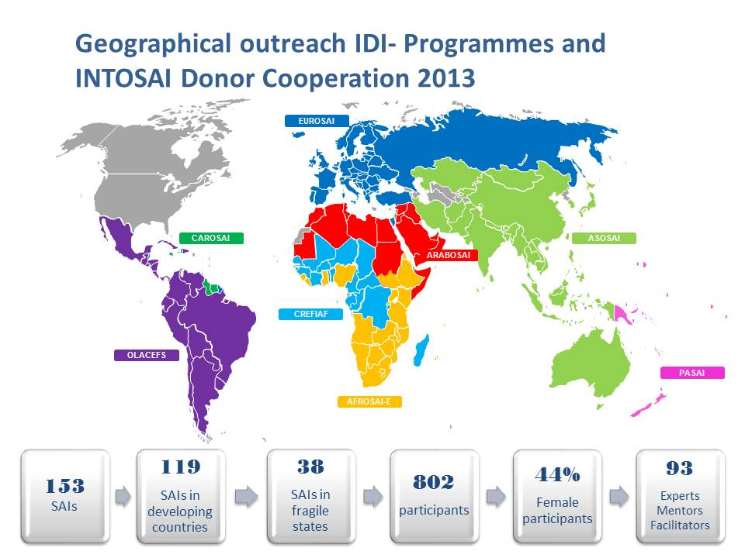

Professional Capacity Development
802 participants of whom 44% were female benefited from the IDI programmes during 2013. This included SAI staff and also staff from donor organisations. 93 resource persons from the SAI community have been involved in these programmes. 509 SAI personnel have been certified through the IDI’s five certification programmes during the year. 100 SAI leaders and managers participated in capacity development activities. During the year a number of global public goods were created which include the ISSAI Compliance Assessment Tools and ISSAI Implementation Handbooks for Performance, Financial and Compliance Audits. IT Audit Handbook was also developed. Structured courseware was developed and updated. There was an increased use of e-learning in the IDI programmes. In 2014, by the end of September 847 participants have benefited from IDI programmes, including 359(42%) female participants.
IDI programmes in 2013 delivered professional capacity development in the areas of ISSAI implementation, IT Audit, Public Debt Audit, Strategic Planning, Risk Based Approach to Audit, Implementation of CBC Guidance, Train the Trainers, SAI PMF and writing funding proposals. During 2014, the programmes on ISSAI implementation, IT Audit, Public Debt Audit, SAI PMF and Implementation of CBC Guidance are continuing. In addition there are programmes on Audit of Externally Aided Projects in Agriculture and Food Security. Through its capacity development interventions the IDI both contributes to the development of global public goods that are available to the entire SAI community and other stakeholders, and to the dissemination and implementation of the various standards and guidance material developed by INTOSAI and the INTOSAI regions. In 2013, the IDI developed ISSAI Implementation Handbooks for Financial and Performance Audit and collaborated with the INTOSAI Working Group on IT Audit develop an IT Audit Handbook, which was endorsed at INCOSAI 2013. The IDI also contributed to AFROSAI-E’s IT Audit Manual which was disseminated to 11 SAIs in AFROSAI-E.
The IDI also contributed to the development and dissemination of other global goods, which included
- ISSAIs – The ISSAIs developed by PSC, FAS, PAS, CAS - Level 2 and Level 4 ISSAIs for Financial, Performance and Compliance Audit disseminated through the 3i Programme, ERBAFA, SAI PMF and Cooperative Performance Audit in PASAI.
- CBC Guidance on – Human Resource Management, Increasing the Impact of Audit Reports, Strategic Considerations in Implementing ISSAIs were disseminated through the IDI-CBC cooperation programme and 3i Programme
- Public Debt Audit – the ISSAIs developed by Working Group on Public Debt and UN principles on responsible borrowing and lending are being disseminated through an IDI programme that started in 2013.
The IDI also facilitated dissemination of global public goods by arranging for their translations.

Organisational Capacity Development
Besides the above professional capacity development, IDI has facilitated the development of organisational capacity in terms of the first strategic plans for SAIs in French speaking Africa and quality assurance in Asian SAIs. Performance audit capacity in SAIs of the Pacific and IT Audit capacity in English speaking Africa have been developed. Since 2012, the IDI with the mandate of the INTOSAI is running a global programme for implementing the International Standards for Supreme Audit Institutions (ISSAIs). ISSAI Implementation Tools have been used by the SAIs in the five English speaking regions.
The IDI has in 2013-2014 also continued to support the capacity development of the INTOSAI regions.
- The IDI supported regional secretariats in AFROSAI-E, ARABOSAI and PASAI through the provision of institutional strengthening managers and capacity building advisors who were engaged in key capacity development activities in the regions.
- The IDI also provided inputs in the development of PASAI strategic plan and implementation of CAROSAI strategic plan
- The IDI contributed a to the OLACEFS GTANIA’s e-course on creating ISSAI awareness.
- The IDI contributed to the EUROSAI Seminar on Performance Audit ISSAIs and the EUROSAI Task Force on Audit and Ethics

The INTOSAI-Donor Secretariat
The INTOSAI-Donor Cooperation is making good progress in its work to increase strategic focus and coordination for Donors and the SAI community in strengthening SAI capacity in developing countries. Since the initial signing of the Memorandum of Understanding in 2009, the number of donors now stands at 21.
Other activities include:

SAI Capacity Development Database
In January 2012, a SAI Capacity Development Database on support to the SAI community was launched to enhance coordination of support. By August 2014 close to 350 projects had been registered by SAIs, INTOSAI Regions and other INTOSAI bodies, donors and private sector suppliers. The database has been used for analytical purposes (including estimation of the total level of SAI capacity development support) as well as for coordination purposes in the process of matching project proposals from the 2013 Global Call for Proposals with providers of support.

2013 Global Call for Proposals
During the fifth INTOSAI-Donor Steering Committee meeting in October 2012, it was decided that the Global Calls for Proposals for SAI capacity development proposals in need of support will be carried out annually at fixed intervals. The second Global Call for Proposals was launched at the 6th INTOSAI-Donor Steering Committee meeting on 19-20th October 2013 in Beijing, China. 48 concept notes were received. The concept notes include nine initiatives from INTOSAI regions and sub-regions, four global initiatives, and 35 country-level initiatives. Concept notes were received in Arabic, English, French, Portuguese, Russian and Spanish. The sum of the financial support sought is USD 57 million.

Establish SAI Capacity Development Fund
The global pooled fund (SAI CDF) has been established with SECO, Switzerland as the first donor.

SAI Performance Measurement Framework
A framework to measure SAI Performance (SAI PMF) has been developed by a Task Team under the auspices of the Working Group on the Value and Benefits of SAIs (WGVBS). The Secretariat is coordinating the Task Team that is developing the framework on behalf of the WGVBS. After a first phase of piloting and consultation of the framework, a Pilot Version was endorsed by the WGVBS during its 6thmeeting in Lima, 3-5 July 2013 to go through a second and wider round of piloting, where 24 SAIs have committed to go through the assessment. The pilot phase will continue in 2015 before being refined for consideration at INCOSAI 2016. The INTOSAI-Donor Secretariat has delivered 15 SAI PMF training courses in five languages covering about 500 potential assessors.

4. Capacity Development Initiatives in the new strategic planning period.
Based on the global survey results and the prioritization process followed in the IDI, the IDI identified six areas of capacity development focus during its current strategic planning period.
The IDI will start work with at least two of these focus areas in 2015. The IDI will engage in further dialogue with its regional partners, SAIs, INTOSAI partners and other professional partners to finalise the results frameworks for each area. Taking into consideration the tremendous benefits derived from e-learning, the IDI has launched a programme to strengthen its own e-learning capacity as well as help SAIs and regions in strengthening their e-learning capacity. This comprehensive capacity development programme will aim to achieve to develop its own learning management system, define its e-learning methodology by developing n e-learning handbook as a global public good, create regional pools of e-learning and LMS specialists, support interested regions and SAIs in developing their e-learning capacity and build a IDI portfolio of e-learning programmes, which can be delivered on a regular basis.
The global survey also shows a very high demand for a capacity development needs in the area of auditing fraud and corruption, SAI Performance Measurement and Reporting, SAI-Stakeholder Relations and Institutional Capacity Development for SAIs-Independence and Legal Framework These would be taken forward in consultation with the stakeholders.

5. Knowledge Sharing and further cooperation with the INTOSAI Committee on Knowledge Sharing and Knowledge Services
The IDI adopted its Knowledge Management Work Plan in 2013. The Knowledge Management action areas and salient initiatives in the Knowledge Management Work Plan included Documentation of the KM requirements of all internal and external stakeholders; Creating Knowledge Resources for use of External and Internal Stakeholders in the form of Global Public Goods, Organise Knowledge Resources, Disseminate Knowledge Resources and facilitate the application of knowledge resources.
In the new IDI Strategic Plan 2014-2018, the IDI has recognised the importance of knowledge management and knowledge sharing by making it integral to the IDI Outcome 3 of the Strategic Plan which talks about among other things developing knowledge networks and communities of practice. Knowledge sharing and implementation of good practices is also integral to the IDI’s new mandate
One of the salient developments during 2013 was the launch of the 3i Community Portal as a knowledge sharing portal and community of practice for ISSAI implementation. Since May 2013 this portal has had about 10,000 visits and the resources available there have been downloaded over 5,000 times. To further build up on the success of the 3i Community Portal, the IDI has recently obtained the services of an E-learning and IT Services Manager. During the coming year the IDI plans to develop a community portal to serve as communities of practice cutting across the professional requirements of public sector auditing. To sustain the portal and communities of practice the IDI would need to engage with the INTOSAI Committee on Knowledge Sharing and Knowledge Services and the different working groups on a sustained basis.
As mentioned in the above paragraphs about ongoing IDI programmes and proposed programme areas, the IDI will continue to draw on the support from the different working groups as it has done over the years. In line with IDI’s cooperation with the INTOSAI Professional Standards Committee and INTOSAI Capacity Building Committee, the IDI will also strengthen its engagement with the INTOSAI Committee on Knowledge Sharing and Knowledge Services.
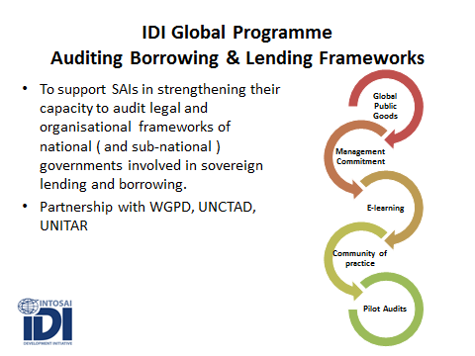 | 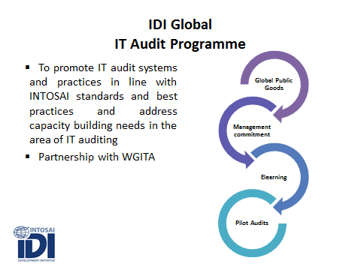

For further information please visit www.idi.no; 3i Community Portal at www.idicommuity.org; for requests for IDI Newsletter and INTOSAI-Donor Cooperation Newsletters please send a request to idi@idi.no. IDI also provides regular updates to the International Journal of Government Auditing.

Defined as per the Committee of Sponsoring Organizations of the Treadway Commission (COSO). COSO is a joint initiative of the American Accounting Association, American Institute of CPAs, Financial Executives International, Association of Accountants and Financial Professionals in Business and Institute of Internal Auditors.

