# 

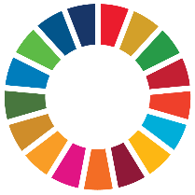 **BACKGROUND**

The 2030 Agenda for Sustainable Development and the 17 Sustainable Development Goals (SDGs) constitute an ambitious and long-term plan of action to eradicating poverty and ensuring sustainable development.

The 2030 Agenda outlines a follow-up and review process. The resolution adopted by United Nations General Assembly on 25 September 2015, “Transforming Our World: The 2030 Agenda For Sustainable Development,” noted that “Our Governments have the primary responsibility for follow-up and review, at the national, regional and global levels, in relation to the progress made in implementing the Goals and targets over the coming fifteen years.”

Theme I of the XXII International Congress of Supreme Audit Institutions (INCOSAI) addressed the contribution and the role of SAIs with regard to reviewing and monitoring the implementation of the SDGs. The Congress highlighted the importance of, and interest in, undertaking audit and review work on the SDGs through four different approaches.

The outcome document of the INCOSAI, the Abu Dhabi Declaration, stresses the need and demand for

effective public audit and scrutiny of the implementation of the SDGs.

INTOSAI plans to provide regular feedback to its community on SDG-related audit issues, such as approaches, methodologies and results, in order to engage with, inform and encourage SAIs to do effective work in this area.

INTOSAI Strategic Plan 2017-2022 identifies contributing to the follow-up and review of the SDGs within the context of each nation’s specific sustainable development efforts and SAIs’ individual mandates as a crosscutting priority. The plan also speaks of the KSC-IDI Auditing SDGs programme, launched in 2016, as a contribution to INTOSAI efforts by supporting SAIs in conducting high quality audits of sustainable development goals.

In 2015, the KSC and IDI launched the SDG community portal, advocated the role of SAIs in auditing SDGs and published a draft version 0 of *‘Auditing Preparedness for Implementation of SDGs – A guidance for Supreme Audit Institutions’(*[*www.idi.no*](http://www.idi.no)*).*

The next stage of the programme is supporting SAIs to conduct a cooperative performance audit of preparedness for implementation of the SDGs. Initially KSC and IDI had planned to support about 40 English-speaking SAIs. However, the programme has seen immense demand from the regions and SAIs. More than 100 SAIs in all INTOSAI regions have indicated an interest in participating in the audit of preparedness. In light of the tremendous interest in the programme, the IDI has decided to scale up the programme in 2017.

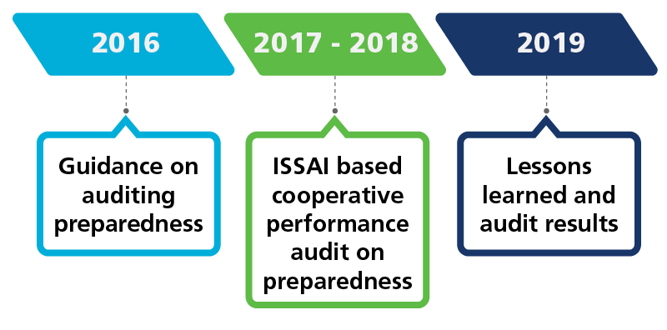

**Advocacy & Awareness Raising**

**Community of Practice**

**PARTNERS**

This programme is a partnership with:

* Supreme Audit Institutions. These include those that will be participating in the cooperative audit and those that provide valuable in kind contribution for the programme, including experts and hosting programme events.
* the Division for Public Administration and Development Management (DPADM) of the United Nations Department of Economic and Social Affairs (UNDESA).
* INTOSAI bodies like INTOSAI Knowledge Sharing Committee (KSC) and the Working Group on Environment Audit (WGEA).
* all INTOSAI regions.
* CCAF – a Canadian research and educational foundation that works primarily with performance audit.
* International Budget Partnership – An organization that collaborates with civil society around the world to analyze and influence public budgets in order to reduce poverty and improve the quality of governance.

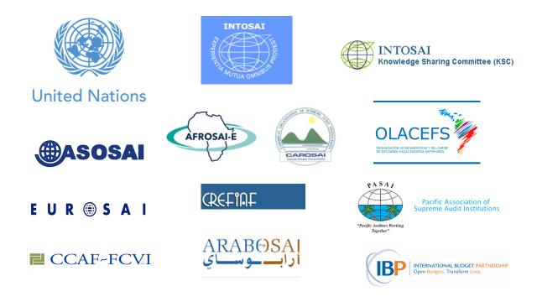

**OBJECTIVE**

The main objective of this programme is to support SAIs in conducting ISSAI based cooperative performance audits of preparedness for implementation of SDGs in their national contexts.

This audit is envisaged as one of the first responses of SAIs in contributing to SDG implementation, follow-up and review by providing independent oversight on the government’s efforts in the early implementation of the SDGs. It will also give SAIs a voice in the implementation and follow-up and review of the SDGs in their countries and ensure that they are not left behind.

**PARTICIPATING SAIs**

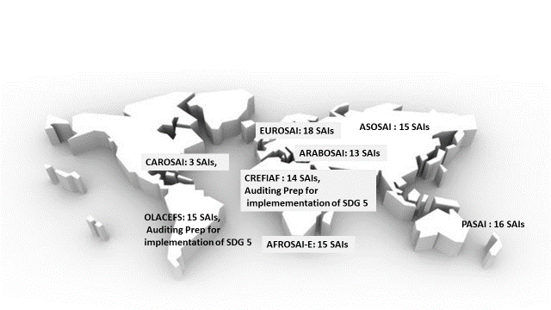As mentioned above, more than 100 SAIs from all INTOSAI regions have expressed interest in participating in the cooperative audit. All SAIs that prioritised the programme will be invited to participate in the cooperative audit.

However, only those SAIs that fulfil the SAI readiness requirements and agree to provide SAI commitments detailed in the subsequent part of this announcement will be selected to participate in the cooperative audit.

**PERFORMANCE AUDIT OF PREPAREDNESS FOR IMPLEMENTATION OF SDGs**

This cooperative audit will be a ***performance audit based on ISSAIs.*** A team of experts and resource persons have worked together to develop an audit model that provides guidance on ‘how to’ plan, conduct and report an audit of preparedness as per performance audit ISSAIs.

SDGs are integrated and indivisible and require a ***whole of government approach*** in their implementation. The concept of ‘whole of governement’ has been described as an overarching term for a group of responses to the problem of increased fragmentation of the public sector and public services and a wish to increase integration, coordination and capacity (Ling, 2002). Consequently, this performance audit will adopt a whole of government approach to look at government’s early efforts in the implementation of the SDGs.

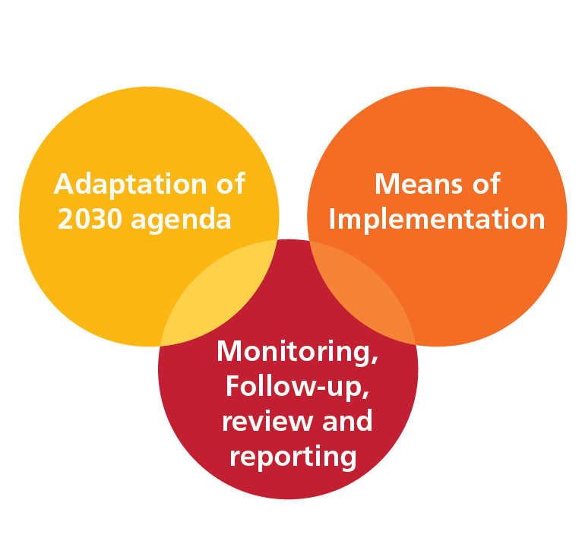***The proposed audit objectives are aligned to the voluntary common reporting guidelines for voluntary national reviews*** *at*the UN’s High Level Political Forum for Sustainable Development (HLPF). This audit of preparedness will be undertaken with three audit objectives.

**Audit Objective 1** – To what extent has the government adapted the 2030 agenda into its national context?

**Audit Objective 2** – Has the government identified and secured the resources and capacities (means of implementation) needed to implement the 2030 Agenda?

**Audit Objective 3** – Has the government established a mechanism to monitor, follow-up, review and report on progress towards the implementation of the 2030 Agenda?

Implementation of the SDGs requires the involvement of a wide variety of government and non-government actors, including citizens and the private sector. As such, this audit of preparedness will also involve intense and ***wide stakeholder engagement*** throughout the audit process to examine the participation, involvement and collaboration between different stakeholders in mainstreaming the 2030 Agenda, mobilizing resources and putting in place mechanisms for monitoring, follow up and review.

Since this will be the first audit carried out on SDGs, we generally recommend that SAIs examine the three audit questions across the ***entire agenda***. However, if SAIs wish to scope their audits more narrowly, it is also possible to tailor the three audit objectives to look at ***specific goals and targets***. For example, in OLACEFS and CREFIAF, this model will be adapted to look at preparedness for implementation of Goal 5: Gender equality.



**Cooperative Audit Calendar**

The following set of activities are planned as part of this cooperative audit programme.

**Invitation, SAIs Readiness & Commitment**

**April – May 2017**

All SAIs that expressed interest in the Auditing SDGs programme will be invited to participate in the cooperative audit. SAIs will be asked to apply based on their readiness commitment (criteria listed as Annexe 1). SAIs that meet both readiness and commitment criteria will be accepted as participating SAIs in the cooperative audit.

**eLearning Course on Performance Audit of preparedness for implementation of SDGs**

**July - August 2017**

This will be an eight-week mentor led eLearning course, delivered on IDI’s learning management system. SAI audit teams will be exposed to key features of the 2030 Agenda and SDGs. They will also be trained in applying whole of government approach and performance audit ISSAIs to the audit of preparedness.



**Cooperation Meeting of SAIs and Stakeholders**

**July 2017**

The IDI and UNDESA will cooperate to organize a two-day cooperation meeting of SAI management and key stakeholders. Besides bringing together stakeholders for a discussion on key issues related to the audit of preparedness, the meeting will also provide an opportunity to reaffirm stakeholder commitments in carrying out the audit. The meeting is planned to be held at UN Headquarters in New York, right after the UN High Level Political Forum 2017.

**Online support for SAIs Planning Audit of Preparedness**

**August - October 2017**

SAI teams will plan the audit during August to October 2017. They may use the tools and working papers provided during the eLearning course. The mentor team will provide online support to the teams on the IDI eLearning platform during this period.

**Audit Planning Meeting**

**November - December 2017**

All audit teams who complete their draft audit plans will be invited to a face-to-face audit planning meeting. At this meeting, experts/mentors and peers will review and provide feedback on the draft audit plans. Tools and techniques related to data gathering and data analysis will also be discussed.



**Online support for SAIs Conducting Audit of Preparedness**

**January - March 2018**

Based on the feedback received, the audit teams are expected to finalise their audit plans, obtain management approval and conduct the audit by gathering evidence, analyzing data, developing audit conclusions and recommendations. As the audit teams conduct the audits, they will have online access to the mentors and experts to seek clarifications and support during the audit process.



**Audit Review Meetings**

**May - June 2018**

The audit teams who complete their draft audit reports will be invited to participate in an audit review meeting. At this meeting, a team of mentors/experts and peers will provide feedback on the draft audit report. Communications experts will also be brought in to provide inputs on the drafts so as to craft the key messages.



**Quality Assurance Workshops**

**2019**

As each audit is expected to be an audit as per performance audit ISSAIs, all SAIs participating in the programme will be invited to a quality assurance workshop. At the workshop, independent quality reviewers will review the working papers to provide

assurance that the audit has been done as per performance audit ISSAIs.



**Compendium of Audit Findings**

**2019**

# A compendium of audit findings will be developed based on the published audit reports of SAIs participating in the cooperative audit.



**Lessons learned and exit meeting 2019**

# The IDI and KSC will facilitate a process to document the lessons learned from the cooperative audits and to discuss sustainability measures after this programme ends. The document on the lessons learned will be globally available through the KSC-IDI community portal in 2019.

**Annexe 1: SAI Readiness and SAI Commitment**

**Each participating SAI will be required to fulfil the following criteria and to commit with the following requirements.**

|  |  |
| --- | --- |
| SAI Readiness Criteria | |
| 1. | SAI has the mandate to conduct performance audits. |
| 2. | SAI uses / intends to use ISSAIs or national standards aligned to ISSAIs in conducting performance audits. |
| 3. | SAI has at least three years of experience in conducting performance audits. |
| 4. | SAI team has demonstrated experience in performance audit. |
| 5. | The country has started making efforts to implement 2030 Agenda. |
| 6. | SAI has access to information related to preparedness and implementation of SDGs and 2030 Agenda. |

|  |  |
| --- | --- |
| SAI Commitments | |
| 1. | SAI will include this audit in its annual audit programme. |
| 2. | SAI will nominate an audit team as per prescribed criteria. |
| 3. | SAI agrees to use the audit approach defined for this cooperative audit. |
| 4. | SAI will provide time and resources for the team to participate actively in the eLearning and to conduct the audit as per the program’s timelines. |
| 5. | SAI has an experienced performance audit team. |
| 6. | SAI will assign a middle level manager to supervise the audit team. This manager will be an observer in the eLearning course and will ensure that the team meets the agreed timelines. |
| 7. | SAI will not change the audit team members, leader and supervisor during the course of the audit (this excludes factors that are not within the control of the SAI). |
| 8. | SAI will ensure that the audit team completes the eLearning course and participates in the face-to-face meetings. |
| 9. | SAI will issue the audit report as per legal provisions. |
| 10. | SAI will identify measures to sustain this audit practice in the future. |

**REQUIREMENTS FOR SAI TEAM**

Each SAI is required to nominate an audit team consisting of 2 to 3 persons. This would include team leader and team members. Each participating SAI must also identify the middle level manager who will supervise the audit. The team as a whole must meet the following criteria.

|  |  |
| --- | --- |
| **Nomination Criteria** | **Requirements** |
| **Inter Disciplinary Team** | The audit team has to be interdisciplinary, with knowledge and experience of conducting performance audits in economic, social and environmental sectors. |
| **Experience** | Minimum of 3 years’ experience in SAI in performance auditing.  Knowledge on Performance Audit ISSAIs. |
| **Language skills** | All team members must be able to communicate effectively in English (written and verbal). |
| **Stakeholder engagement** | The team should have demonstrated ability to engage effectively with a wide range of stakeholders. |
| **Ability to operate in a web based environment** | The auditors must be able to operate effectively in a web-based environment. |
| **Personal attributes** | SAI team members are expected to be very good team players, innovative, responsible and accountable, respectful of different views and ideas, able to deliver results with quality and on time and to behave ethically at all times. |
| **Gender** | The SAI team should be gender balanced and has to include at least one female participant. |
| **Ability to travel** | The team must be able and willing to travel for face-to-face meetings related to the programme. |